**GROUP 320: CUSTOMER SEGMENTATION AND MARKET BASKET ANALYSIS FOR AN ONLINE RETAIL**

|  |  |  |
| --- | --- | --- |
| First Name | Last Name | Email address |
| Bhavya Sree | Bindela | bbindela@hawk.iit.edu |

Table of Contents

**1. Introduction** 4

**2. Data** 4

**3. Problems and Solutions** 5

**4. KDD** 5

4.1. Data Processing 5

4.1.1. Identify the Customers into different groups based on their behavior with the online retail. 5

4.1.2. Identify best 10 Association rules for the products in the online retail 11

4.2. Data Mining Methods and Processes 17

4.2.1. Identify the Customers into different groups based on their behavior with the online retail. 17

4.2.1.1. K-Means Clustering 18

4.2.1.2. Hierarchical Clustering 22

4.2.2. Identify best 10 Association rules for the products in the online retail 26

**5. Evaluations and Results** 29

5.1. Evaluation Methods 29

5.1.1. Identify the Customers into different groups based on their behavior with the online retail. 29

5.1.1.1. Internal measures 29

5.1.1.2. External measures 30

5.1.1.3. Manual Evaluation 31

5.1.2. Identify best 10 Association rules for the products in the online retail 32

5.2. Results and Findings 33

5.2.1. Identify the Customers into different groups based on their behavior with the online retail. 33

5.2.2. Identify best 10 Association rules for the products in the online retail 35

**6. Conclusions and Future Work** 36

6.1. Conclusions 36

6.2. Limitations 37

6.3. Potential Improvements or Future Work 37

Table of Figures

Figure 1: Load the data and Structure of data 5

Figure 2: Change the type of InvoiceDate 6

Figure 3: check for Missing values 6

Figure 4: Remove the records with Null values in CustomerID 6

Figure 5: summary of input data 7

Figure 6: Filtering out return and Invalid transactions 7

Figure 7: Calculate Recency 8

Figure 8: Calculate Frequency 8

Figure 9: Calculate Monetary 8

Figure 10: Merge Recency, Frequency and Monetary values 9

Figure 11: Structure and Summary of RFM data 9

Figure 12: Check for outliers 9

Figure 13: Boxplot for RFM values 9

Figure 14: Remove Outliers 10

Figure 15: Structure of RFM data after removing outliers 10

Figure 16: Scaling the numerical variables 10

Figure 17: Head rows of clustering data 10

Figure 18: Check for missing values 11

Figure 19: Remove the records having NULL in product name 11

Figure 20: Summary of the Input data 11

Figure 21: Filter out return and invalid transactions 12

Figure 22: Check for the length of unique StockCode and Description 12

Figure 23: Data Format of Description 12

Figure 24: Trim the Description 12

Figure 25: Check for the special characters in Description 13

Figure 26: Check for the lowercase letters in the Description 13

Figure 27: Remove the data with Description as NULL 13

Figure 28: Check for the StockCodes with multiple products 14

Figure 29: List of Products of duplicated StockCodes 14

Figure 30: Correction of Typo errors in Description (ProductName) 15

Figure 31: Structure of data after pre-processing 15

Figure 32: Recheck the length of unique StockCode and Description 15

Figure 33: Get the list of products bought together 16

Figure 34: Structure of the data after transformation 16

Figure 35: Remove column InvoiceNo 16

Figure 36: Change the type of items to factor 16

Figure 37: Write the transformed data to csv file 16

Figure 38: Glimpse of a csv file 17

Figure 39: Calculate Silhouette score with kmeans method 18

Figure 40: Graph for Optimal number of clusters using silhouette method with kmeans 18

Figure 41: KM_Model1 - KMeans model with K as 4 19

Figure 42: KM_Model1 - Graph of clusters 19

Figure 43: KM_Model1 - Size and Centers of Clsuters 20

Figure 44: Calculate optimal number of clusters using Elbow Method with kmeans 20

Figure 45: Graph of optimal number of clusters using Elbow method with kmeans 20

Figure 46: KM_Model2 - KMeans model with K as 3 21

Figure 47: KM_Model2 - Graph of Clusters 21

Figure 48: KM_Model2: Size and Centers of Cluster 21

Figure 49: Calculate Silhouette score with hcut method 22

Figure 50: Graph for Optimal number of clusters using silhouette method with hcut 22

Figure 51: HC_Model1 - Hierarchical model with K as 2 23

Figure 52: HC_Model1 - Dendrogram 23

Figure 53: HC_Model1 - Size and Centers of clusters 23

Figure 54: Calculate optimal number of clusters using Elbow Method with hcut 24

Figure 55: Graph of optimal number of clusters using Elbow method with hcut 24

Figure 56: HC_Model2 - Hierarchical model with k as 3 25

Figure 57: HC_Model2 - Dendrogram 25

Figure 58: HC_Model2 - Size and Centers of cluster 25

Figure 59: Read the data as transactions 26

Figure 60: Association rules with min.support 0.1 and min.confidence 0.1 26

Figure 61: Association rules with min.support 0.05 and min.confidence 0.1 27

Figure 62: Association rules with min.support 0.0293 and min.confidence 0.1 27

Figure 63: Inspect Association rules 28

Figure 64: Prune the Redundant rules 28

Figure 65: Calculate Internal measures 30

Figure 66: Summary of Internal measures 30

Figure 67: KM_Model1 - Centers of Clusters 31

Figure 68: KM_Model2 - Centers of Clusters 31

Figure 69: HC_Model1 - Centers of Clusters 31

Figure 70: HC_Model2 - Centers of Clusters 31

Figure 71: Association rules - Support, Confidence, Lift values 33

Figure 72: Size of the final clusters 34

Figure 73: Summary of Final data 34

Figure 74: Customers of Group1 34

Figure 75: Customers of Group2 35

Figure 76: Best 10 Association rules 35

Figure 77: Graph of Best 10 Association rules 36

# **1. Introduction**

Customer Segmentation and Market analysis for an online retail non-store is to explore different types of customers and their granular purchase behavior.

**Customer segmentation** is the process of dividing the customers into different groups based on their behavior with the company. There will be different types of customers for any firm like some customers will be frequent buyers, some customers will be less frequent but buy high-value products, and so on. These are called different segments of customers. Using customer segments, the company can market their strategies to each group effectively.

**Market Basket Analysis** is a technique to identify the strength of association between pairs of products that are purchased together. This technique is based on a concept that if a person buys a product A, how likely the person will buy a product B.

Therefore, Market Basket Analysis is to uncover the product purchase behavior of customers by extracting the association rules of the products. These will be helpful to understand purchase decisions made by the customers and the company can use the association rules in their future marketing strategies.

# **2. Data**

Dataset belongs to a UK-based registered non-store online retail.

This dataset contains all the transactions that occurred between 01/12/2010 and 09/12/2011.

This dataset has been collected from UCI Machine Learning Repository.

The dataset can be found in the below link

<https://archive.ics.uci.edu/ml/datasets/online+retail>

**Format of the dataset**

Number of Instances: 541909

Number of Attributes: 8

|  |  |  |
| --- | --- | --- |
| **Attribute** | **Description** | **Data Type** |
| InvoiceNo | Invoice number | Character |
| StockCode | Product Code | Character |
| Description | Product Name | Character |
| Quantity | Quantity of each product per transaction | Number |
| InvoiceDate | Invoice Date and Time | Number |
| UnitPrice | Price of the Product per unit | Number |
| CustomerID | Customer Number | Number |
| Country | Country Name | Character |

Table 1: Metadata of the datafile

In this dataset, there is no target variable, as we will be doing unsupervised learning on the online retail dataset.

The whole project will be implemented in R.

# **3. Problems and Solutions**

Below are the research problems identified to solve in this project.

1. Identify the customers into different groups based on their behavior with the online retail. Identify the Loyal Customers.
2. Identify best 10 Association rules for the products purchased in the online retail. I.e., to identify the Products that are frequently bought together in the online retail.

# **4. KDD**

## 4.1. Data Processing

## 4.1.1. Identify the Customers into different groups based on their behavior with the online retail.

* As a first step, load the data into R session.

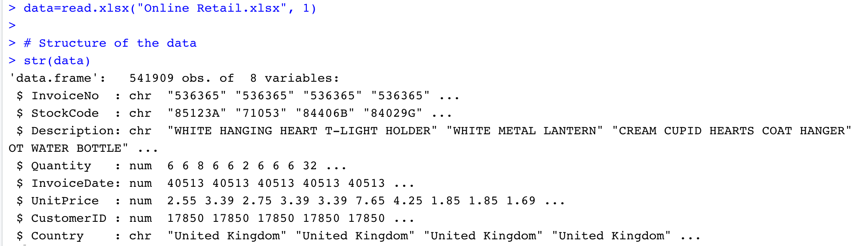

Figure 1: Load the data and Structure of data

As the type of the InvoiceDate is Numerical, changed its type to date.

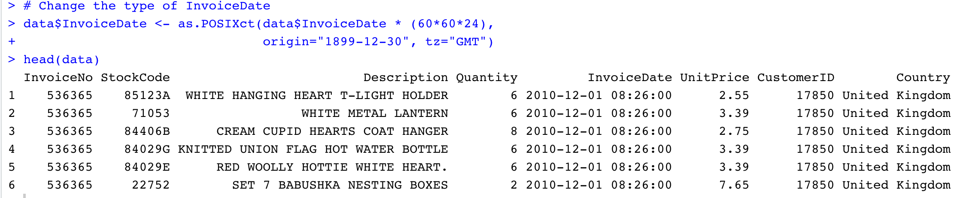

Figure 2: Change the type of InvoiceDate

**(I) Cleaning the data**

* Check for the Missing values



Figure 3: check for Missing values

Data has missing values in Description and CustomerID columns.

As CustomerID is the unique ID given to every customer, we cannot replace the missing values with any valid value. Therefore, removing the records with Null values in CustomerID.

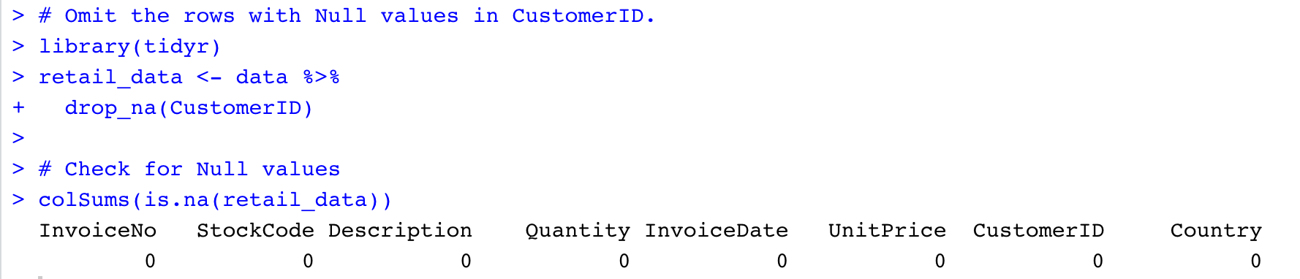

Figure 4: Remove the records with Null values in CustomerID

After removing the records with missing values in CustomerID, there are no more missing values in the data.

* Check the Data Structure (Summary of the data)

Summary of the data is as follows

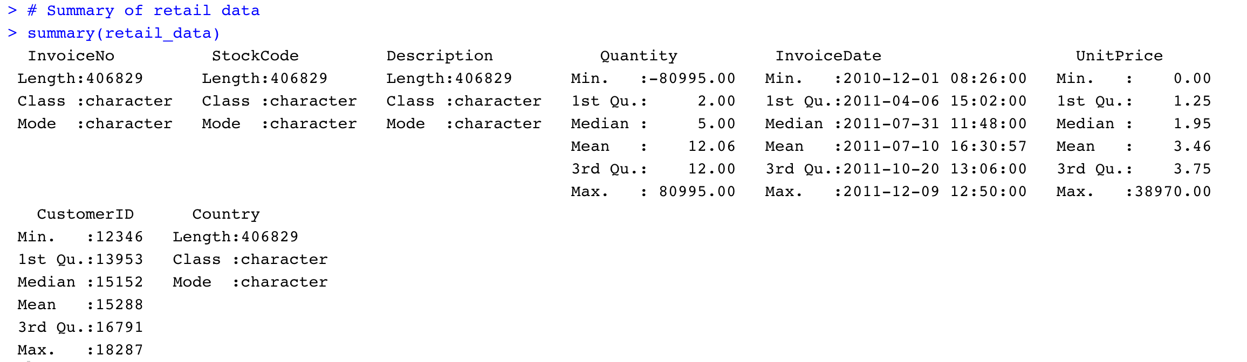

Figure 5: summary of input data

The minimum value of Quantity is identified as -80995.00. The value of Quantity can be negative only in the return transactions. As we won’t be considering return transactions for our analysis, we will be filtering the return transactions out and consider only sales transactions.

The minimum unitPrice is identified as 0.00, which won’t be the case in the sales transactions. Therefore, we will be considering the records, whose quantity is greater than 0.

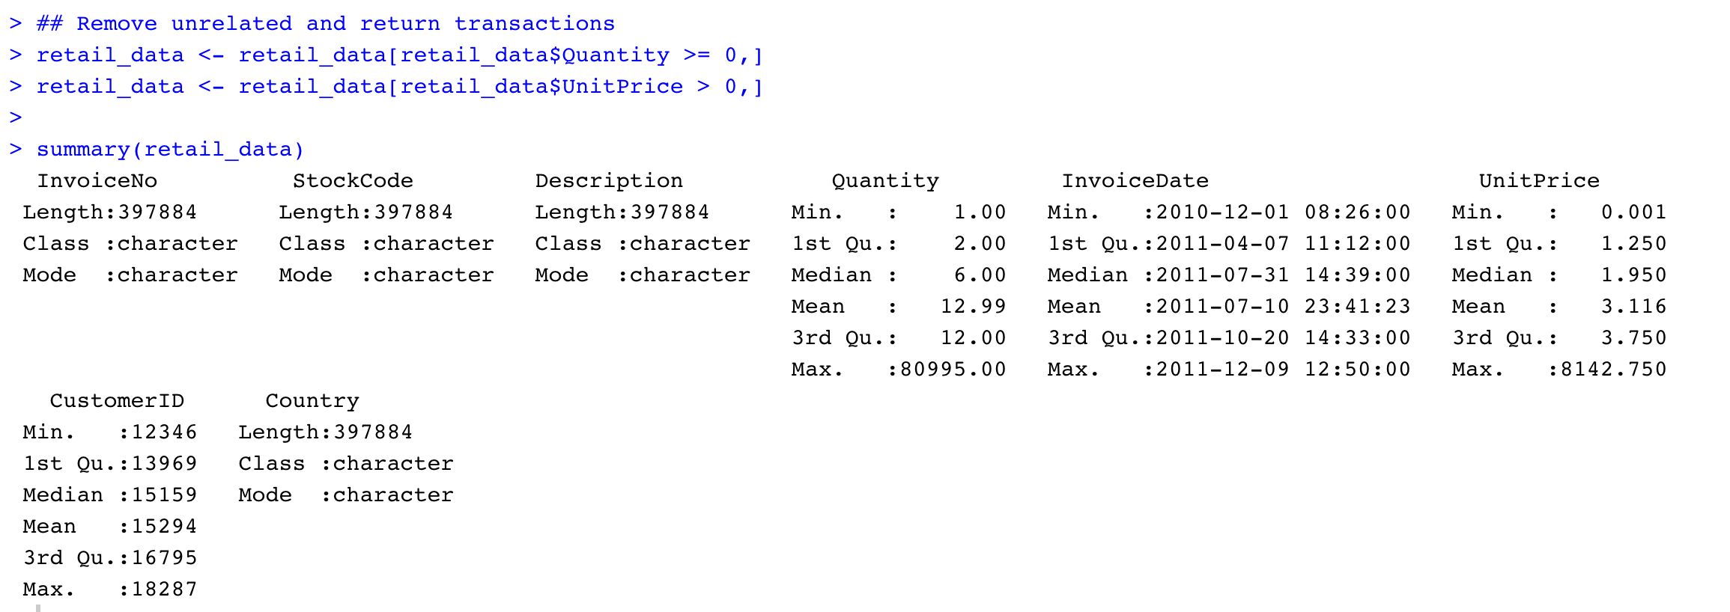

Figure 6: Filtering out return and Invalid transactions

**(II) Transforming the data**

Recency, Frequency, Monetary (RFM) is a data-driven technique that is mostly used for customer segmentation. In this method, we use time from the last purchase (Recency), a total number of purchases in a period of time (Frequency) and total amount spent in a period of time (Monetary) attributes.

As a part of data Transformation, calculate Recency, Frequency, Monetary for every customer and form a new dataset.

Recency is the Number of days from the last purchase. For this, first we will calculate the time difference of every Invoice i.e., difference between max InvoiceDate and InvoiceDate. The minimum time difference of every customer is taken as the Recency.

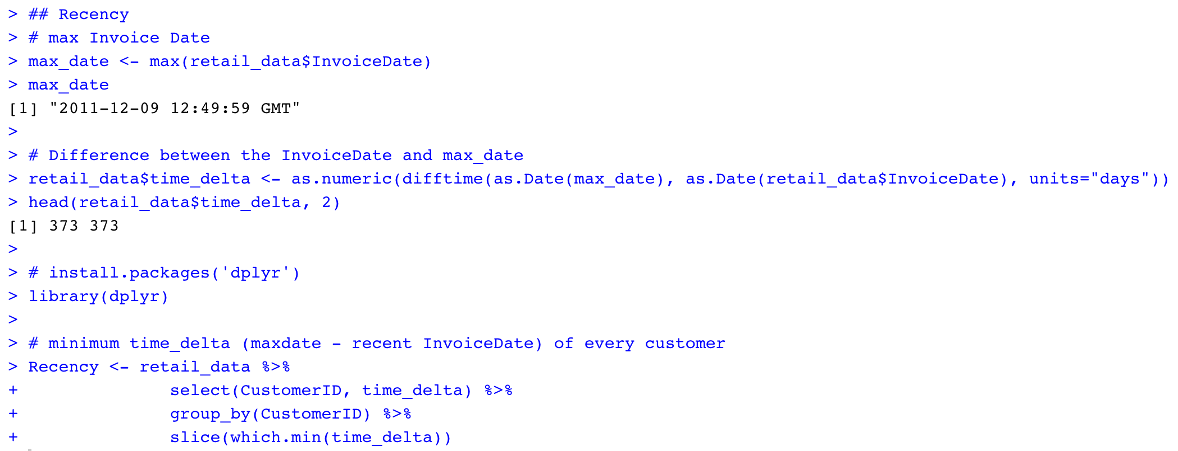

Figure 7: Calculate Recency

Frequency is the number of visits by the customer. To calculate this, we will group the data by CustomerId and get the count of Invoice number.

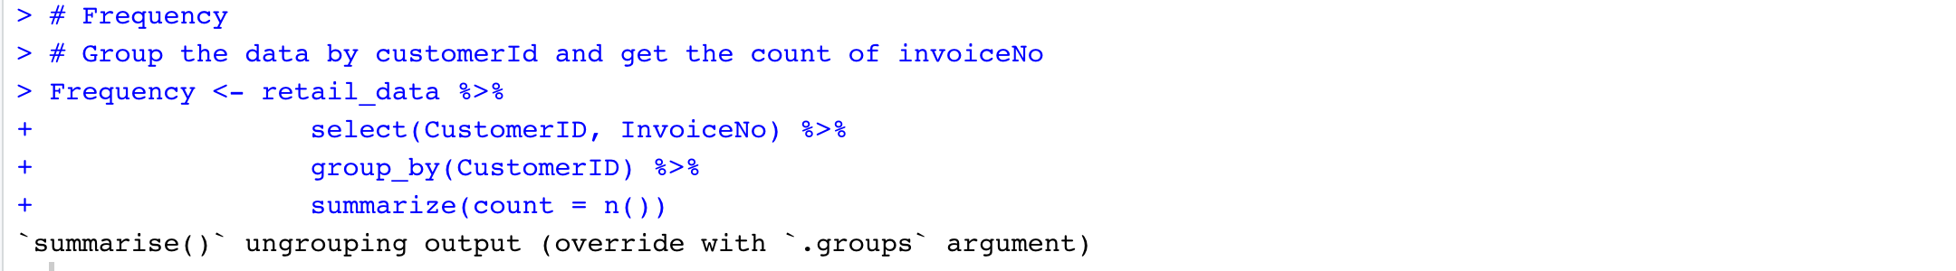

Figure 8: Calculate Frequency

Monetary is the total amount spent by the customer. To calculate this, we will group the data by CustomerId and get the sum of amount spent (UnitPrice * Quantity).

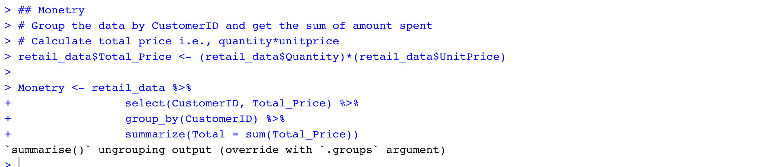

Figure 9: Calculate Monetary

Now merge Recency, Frequency and Monetary values by CustomerID and form new dataset.



Figure 10: Merge Recency, Frequency and Monetary values

Structure and Summary of the RFM data is as below

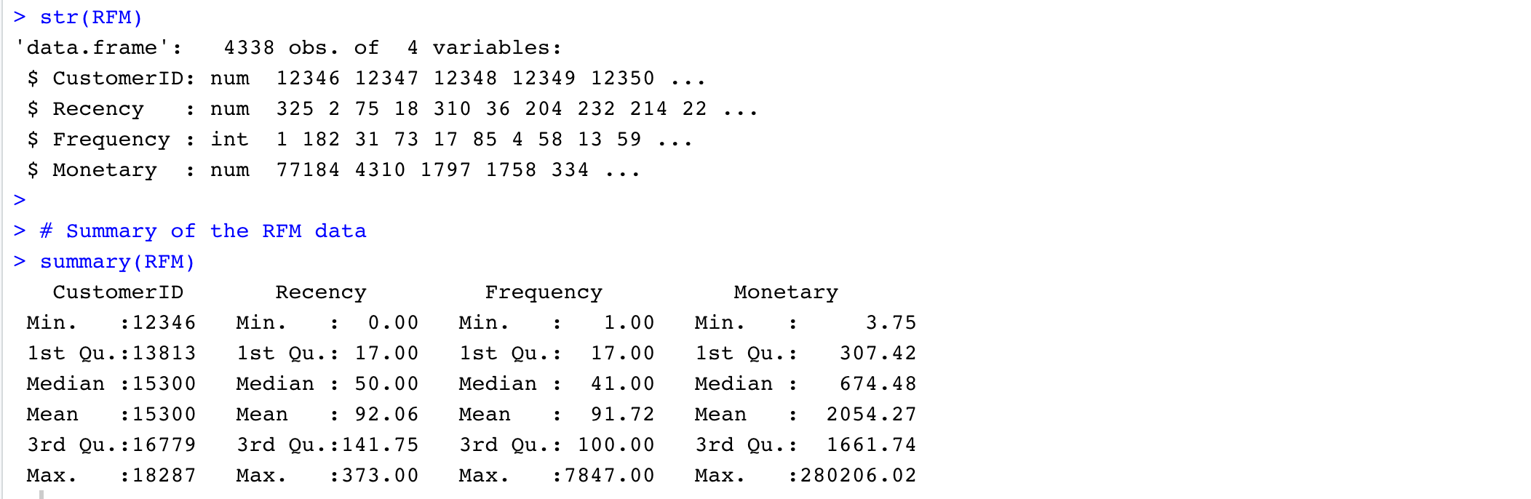

Figure 11: Structure and Summary of RFM data

* Pre-processing the RFM data – Check for the outliers



Figure 12: Check for outliers

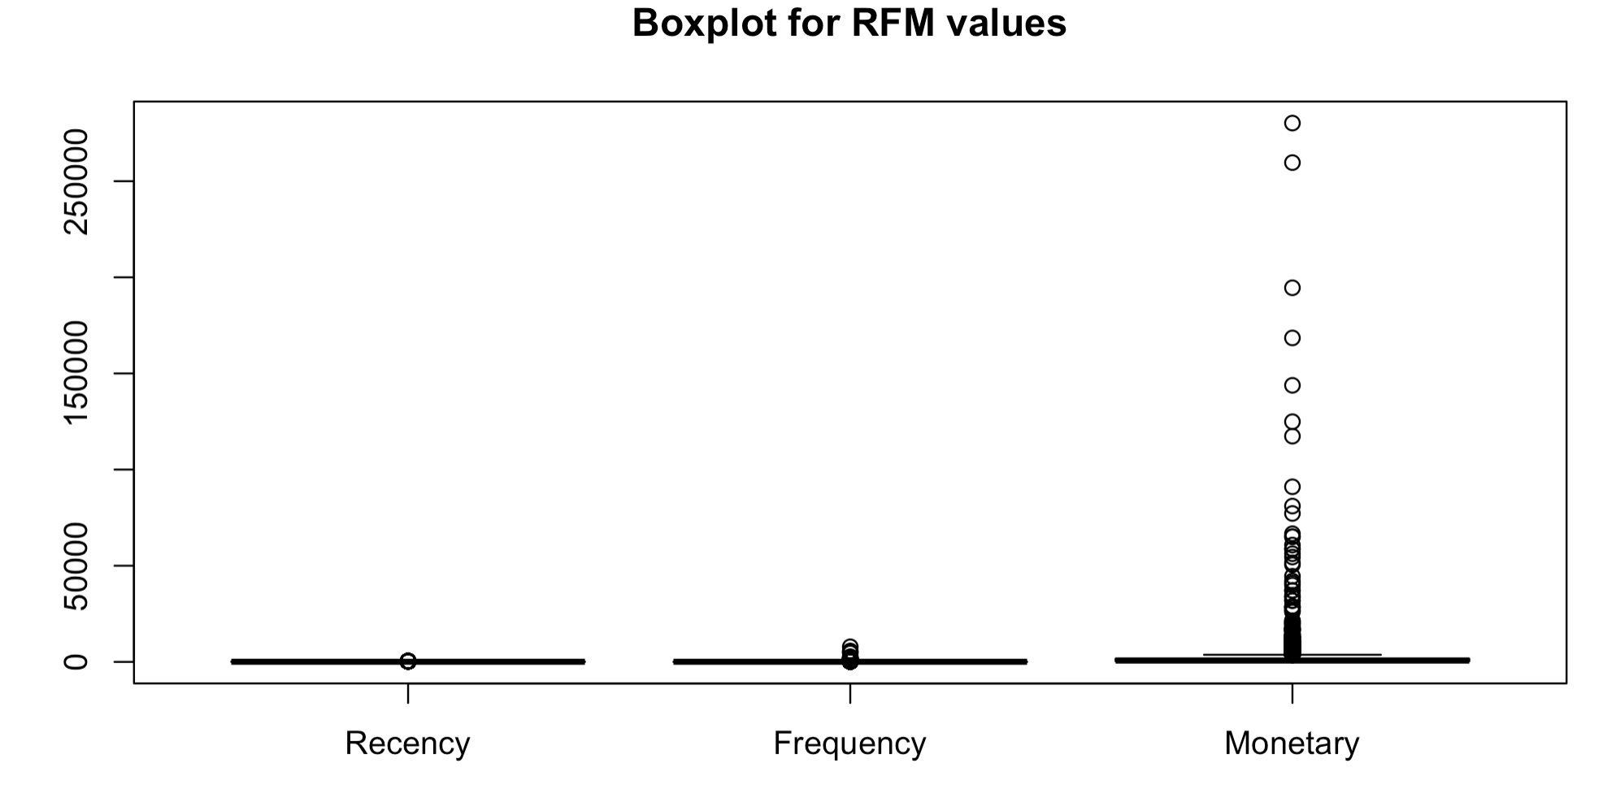

Figure 13: Boxplot for RFM values

From the boxplot, it is clear that Recency, Frequency and Monetary values have outliers.

For customer segmentation, we will be using clustering techniques.

Outliers will have more effect on clustering as they can change the centroids of the clusters. Therefore, we will be removing outliers as the pre-processing for clustering.

Remove Outliers

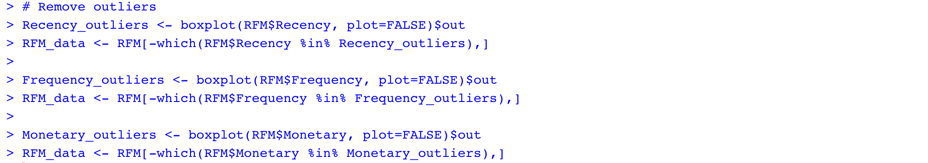

Figure 14: Remove Outliers

Structure of the RFM data after removing the outliers is as below

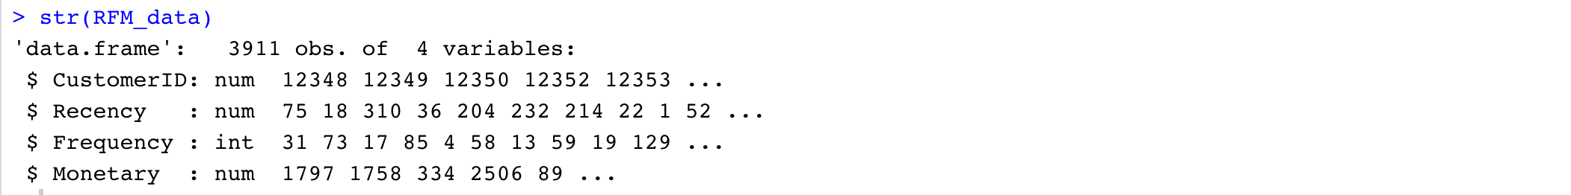

Figure 15: Structure of RFM data after removing outliers

**(III) Standardizing the data**

In order to compare the data and draw conclusions, we need to scale the numerical data.



Figure 16: Scaling the numerical variables

The top rows of the new data (Clust_data) is as below

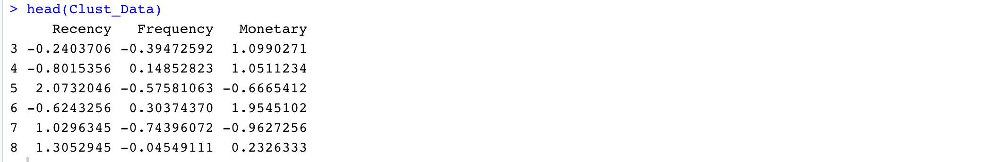

Figure 17: Head rows of clustering data

## 4.1.2. Identify best 10 Association rules for the products in the online retail

This is to identify the Products that are frequently bought together in the online retail.

**(I) Cleaning the data**

* Check for the missing values



Figure 18: Check for missing values

Data has missing values in Description and CustomerID columns.

As description (ProductName) is the main and only one attribute, we use for association rules and the number of missing values is small compared to the total size of the dataset i.e., 541909. We will be removing the records with Null values in Description.

As we won’t be using customerID for this analysis i.e., while building association rules for the products that are brought together.



Figure 19: Remove the records having NULL in product name

Summary of the data is as below

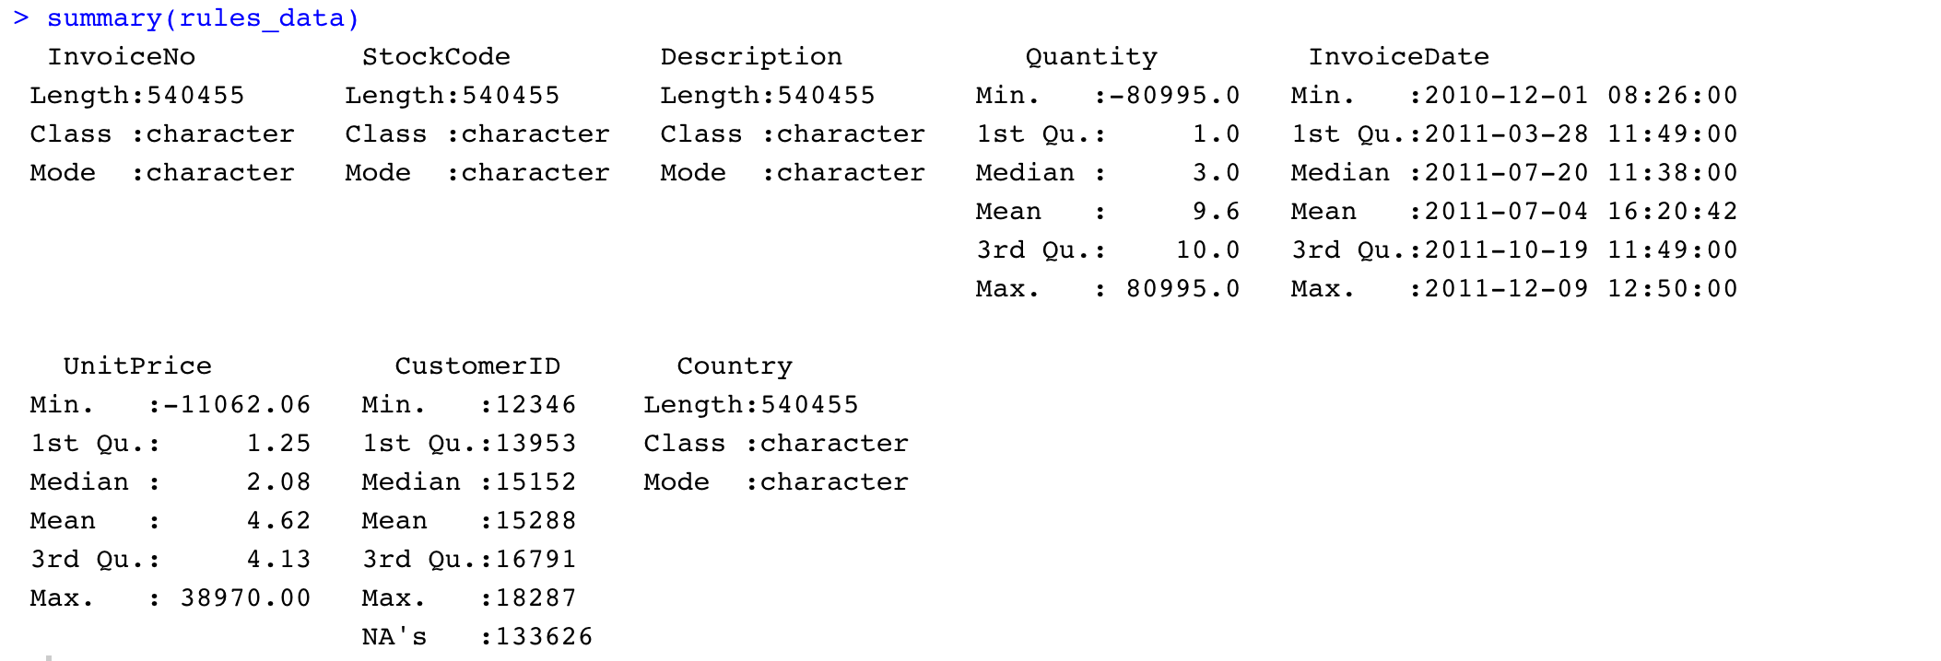

Figure 20: Summary of the Input data

The minimum value of Quantity is identified as -80995.00. The value of Quantity can be negative only in the return transactions. As we won’t be considering return transactions for our analysis, we will be filtering the return transactions out and consider only sales transactions.

The minimum UnitPrice is identified as 0.00, which won’t be the case in the sales transactions. Therefore, we will be considering the records, whose quantity is greater than 0.



Figure 21: Filter out return and invalid transactions

* Check for the presence of irrelevant data in Description (ProductName) attribute.

For this, as a first step, check whether the unique number of StockCodes is same as the unique number of products (Descriptions).

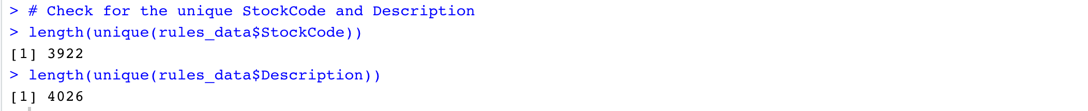

Figure 22: Check for the length of unique StockCode and Description

Generally, each stockCode represents a unique Product and a Product can have more than one StockCode as the StockCode number can be reviewed whenever the product is restoked (after the completion of all products of that StockCode in the shop).

In this case, there are a greater number of products than the stockCode. Therefore, we need to check whether all the Descriptions (ProductName) are valid or not.

Some of the descriptions in the data is as below



Figure 23: Data Format of Description

* Trim the Description (Product Name)

As Description is the type Character, we trim the data to remove any leading and trailing spaces.



Figure 24: Trim the Description

* Check for the special characters in the Description (Product Name)



Figure 25: Check for the special characters in Description

* Check for the lowercase letters in Description

It seems Descriptions are in uppercase letters. Therefore, checking if there are any lowercase letters too in the Description.

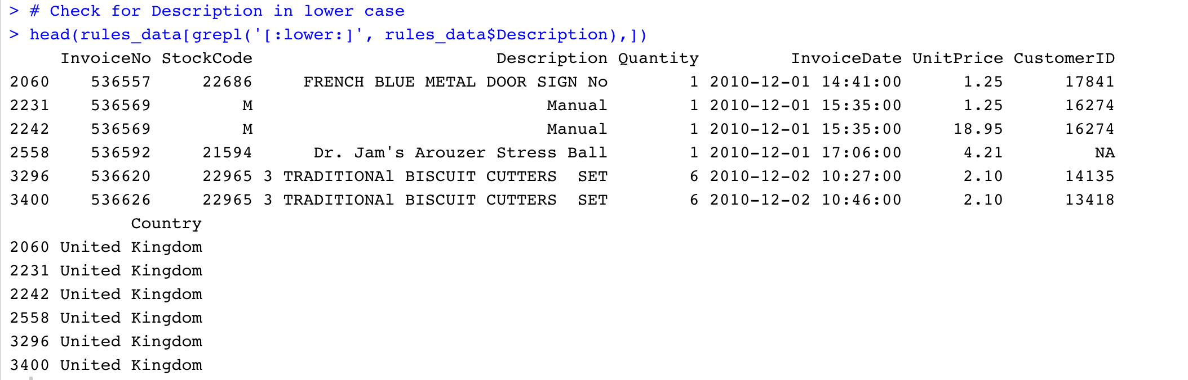

Figure 26: Check for the lowercase letters in the Description

There are many rows with manual as Descriptions (just shown few for reference). As product Name manual makes no sense, we will be removing the records with Manual in Description.



Figure 27: Remove the data with Description as NULL

* Check for the StockCodes with multiple products i.e, Descriptions

To achieve this, first we need to group the data by StockCode and Description and get the unique StockCode and Description. Then check for the duplicate StockCodes in the list of Unique StockCode and Description.

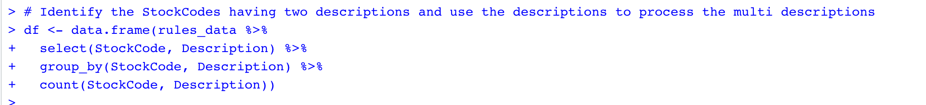

Figure 28: Check for the StockCodes with multiple products

List of the Descriptions of the duplicated StockCodes is as below.

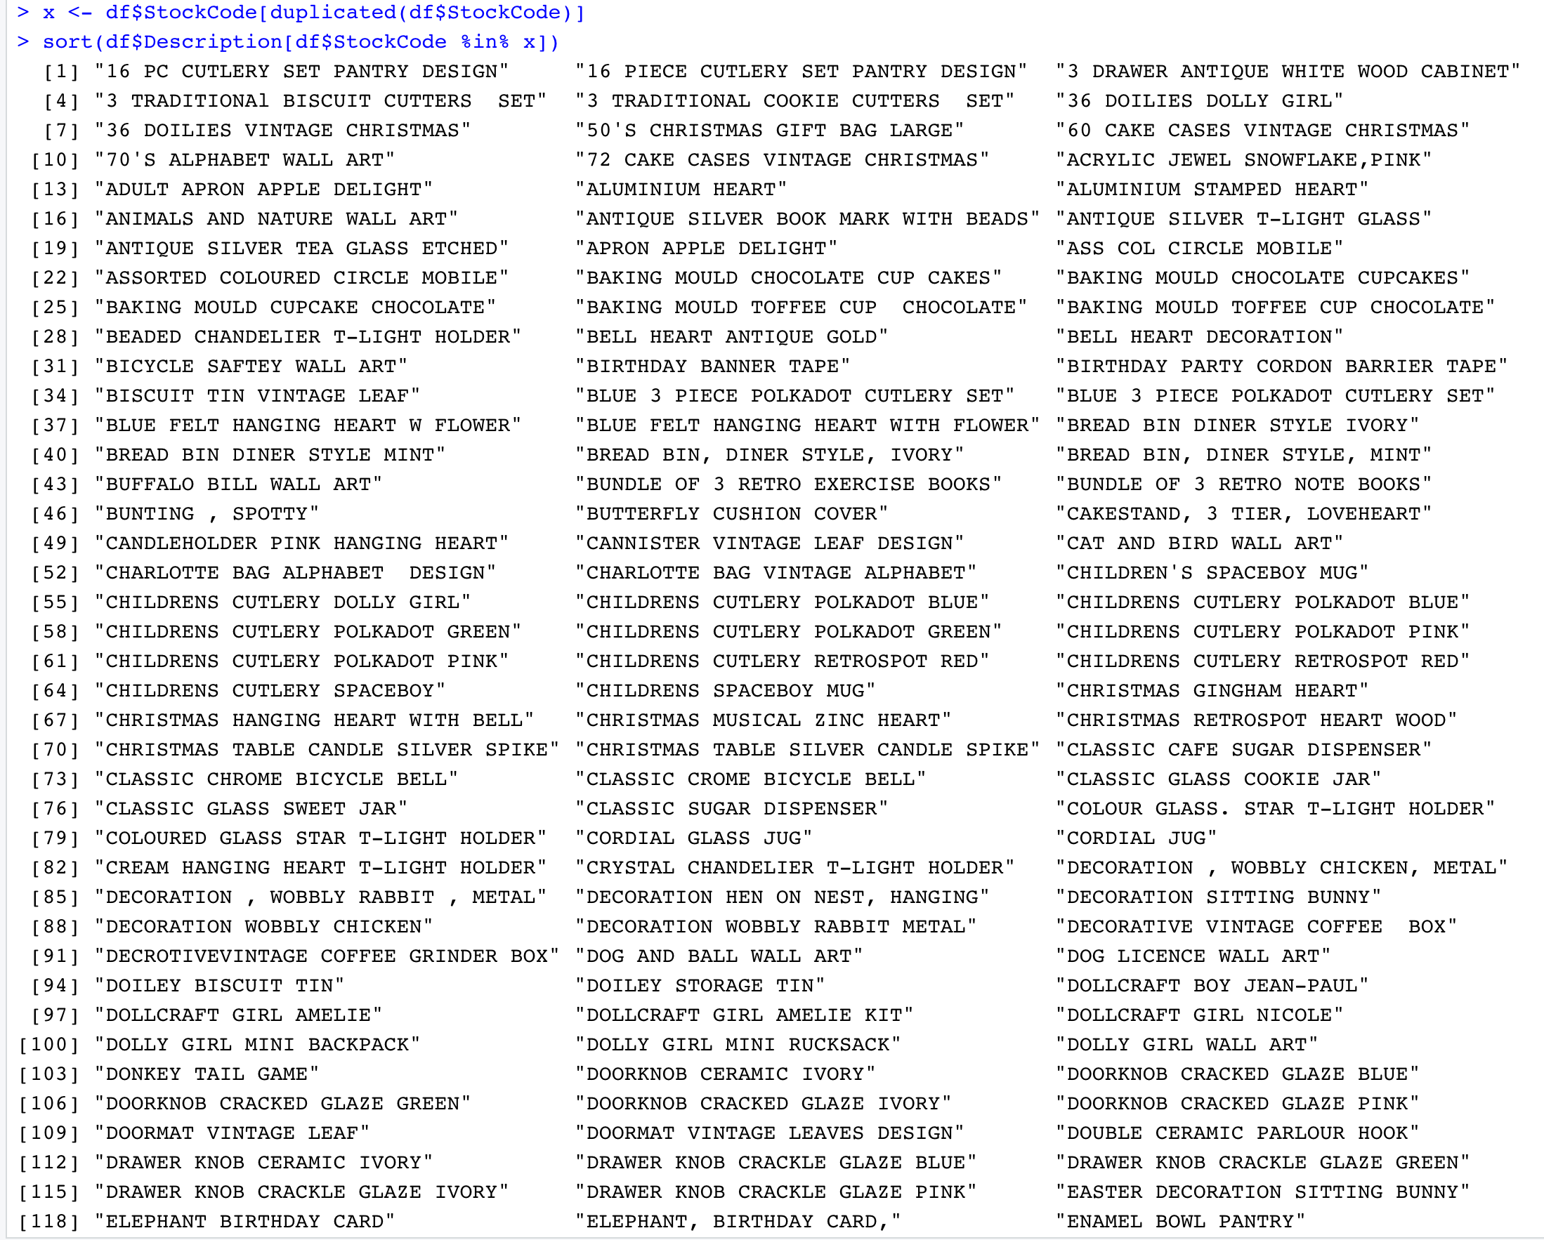

Figure 29: List of Products of duplicated StockCodes

Here, we got a list of 453 Descriptions (given few for reference). When we observer this list, there are many typo errors in the product names.

For example, “16 PC CUTLERY SET PANTRY DESIGN” and “16 PIECE CUTLERY SET PANTRY DESIGN” are same with same StockCode, but these will be treated as different by the data mining techniques and these will affect the support, confidence and lift values of our association rules.

Therefore, we need to treat these typo errors if the description has the same StockCode.

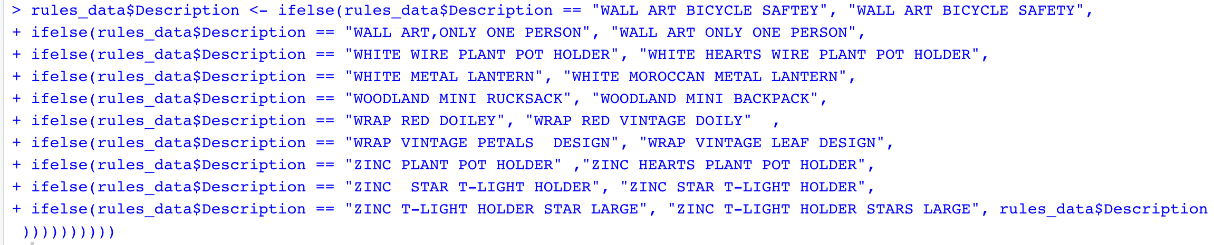

Figure 30: Correction of Typo errors in Description (ProductName)

Treated almost 200 products which are having type errors (just a few are shown for reference, whole code will be available in the code file).

Now, the structure of the rules_data is as below

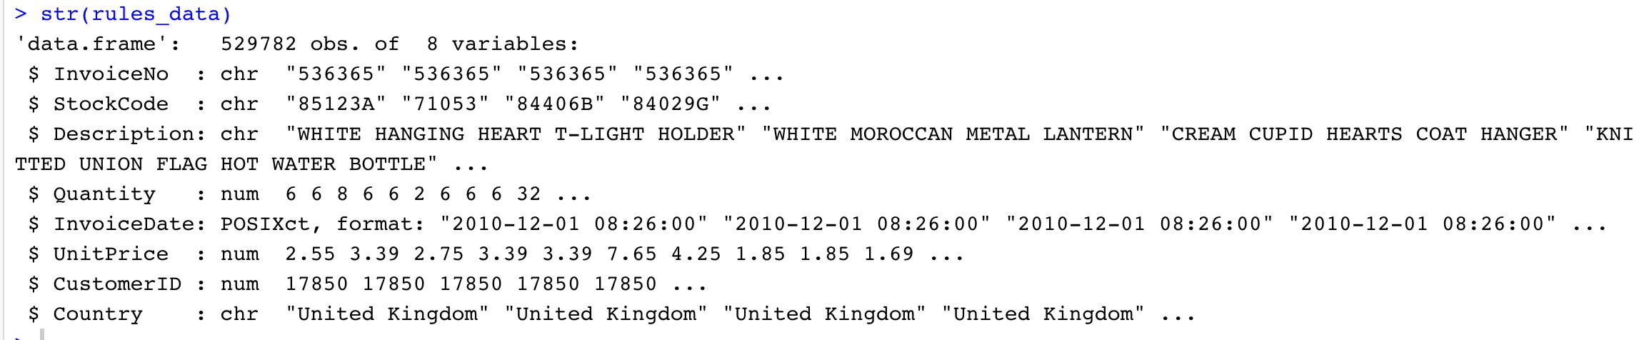

Figure 31: Structure of data after pre-processing

Check for the unique number of StockCodes and unique number of Product Names.



Figure 32: Recheck the length of unique StockCode and Description

Now, the counts look valid as a product can have multiple StockCodes and as we are using product name to get the frequent item sets. This difference won’t be affecting our association rules.

**(II) Transforming the data**

The granularity of our dataset is one line per item.

In order to know the products that are frequently bought together, we need to have all the items bought together in a single row i.e., the granularity of the dataset should be one row per Invoice.

Therefore, to get the items that are bought in a single invoice, we need to group the data by Invoice No and concatenate the products using ‘,’.

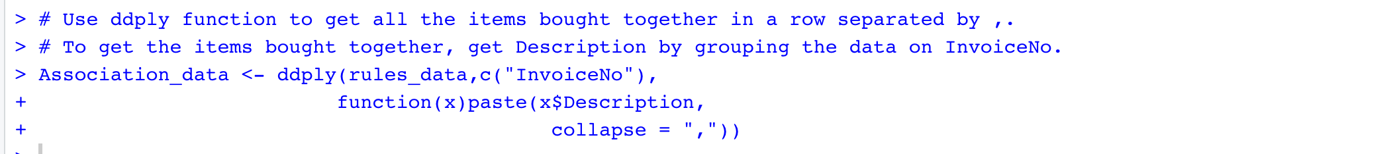

Figure 33: Get the list of products bought together

Structure of the association data is as below

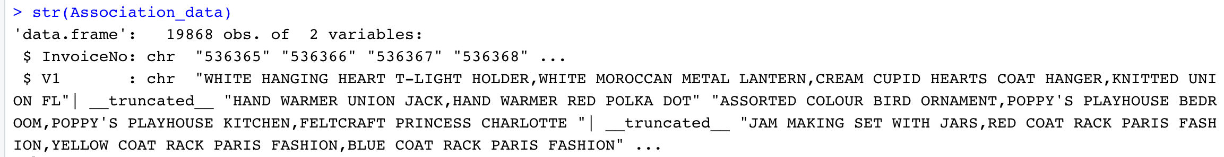

Figure 34: Structure of the data after transformation

Remove the column InvoiceNo, as we won’t be needing it in our process and change the column name from V1 to items.



Figure 35: Remove column InvoiceNo

In order to build the association rules, the attributes need to be the type of factor.

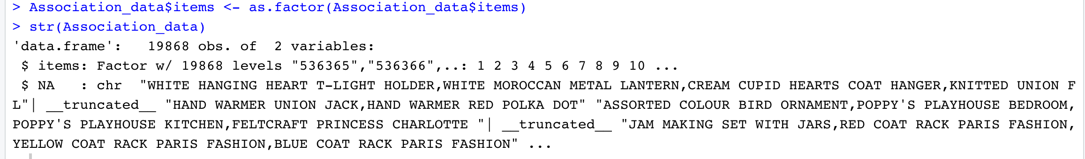

Figure 36: Change the type of items to factor

Association data contains the products that are bought together (i.e., in a single Invoice).

To view this data in better format, writing the association data to a csv file.



Figure 37: Write the transformed data to csv file

The csv file looks like below



Figure 38: Glimpse of a csv file

Each row contains all the products that are bought in a single Invoice.

## 4.2. Data Mining Methods and Processes

## 4.2.1. Identify the Customers into different groups based on their behavior with the online retail.

Clustering is a technique to group the set of objects such that the objects of the same group will have similar characteristics compared to the objects of other groups.

In our case, we need to divide the customers into different groups based on their behavior with the online retail that is, we need to have the customers with similar characteristics as a group. Therefore, Clustering will be the best solution to identify the customers into different groups (customer segmentation).

In this project, we use both K-means Clustering and Hierarchal clusteringalgorithms on RFM data for customer segmentation.

To build Clustering models, as a first step, we need to find an optimal number of clusters our data can be divided into.

In this project we use both Silhouette Method and Elbow to find optimal number of clusters that is K value.

**Silhouette Method**

Silhouette Method is the interpretation and validation of consistency within the clusters. This method calculates the silhouette coefficient for each point to measure how much a point is similar to its own cluster compared to other clusters.

Silhouette Score is average of silhouette coefficients of all data points.

The range of silhouette score is between [1, -1], where +1 indicates that the objects are well matched to its own cluster rather than with neighboring clusters.

Silhouette coefficient of $i^{th}$ point s(i) is calculated as below

$$s\left(i\right)= \frac{b\left(i\right)-a(i)}{max⁡(b\left(i\right), a\left(i\right))}$$

Where a(i) is the average distance of $i^{th}$ point with all other points in the same cluster,

b(i) is the average distance of $i^{th}$ point with all other points in the closest cluster.

**Elbow Method**

Elbow method is used to determine the optimal number of clusters. In this method, a plot is drawn with the value of within-cluster-Sum of Squared Errors (WSS) function produced by different number of clusters and pick the [elbow of the curve](https://en.wikipedia.org/wiki/Elbow_of_the_curve) as the number of clusters to use.

The elbow is the optimal point after which, adding cluster does not worth the diminishing WSS.

WSS is the sum of squared errors in the cluster. Squared Error for a point is nothing but the square of the distance of the point to the centroid of the cluster. The distance between the point and centroid can be calculated using either Euclidean Distance or the Manhattan Distance.

Steps:

1. For each K-value, calculate the total WSS (within sum of squares of all clusters).
2. Plot the graph for K-value Vs total WSS
3. The value of K with a bend in the plot is considered as the appropriate K-value (clusters).

## 4.2.1.1. K-Means Clustering

K-Means Clustering aims to divide the data into K partitions in which each data point belongs to the cluster with the nearest cluster centroid.

* Calculate optimal number of clusters using Silhouette method.

We calculate optimal number of clusters with K-means algorithm for the data using Silhouette method.



Figure 39: Calculate Silhouette score with kmeans method

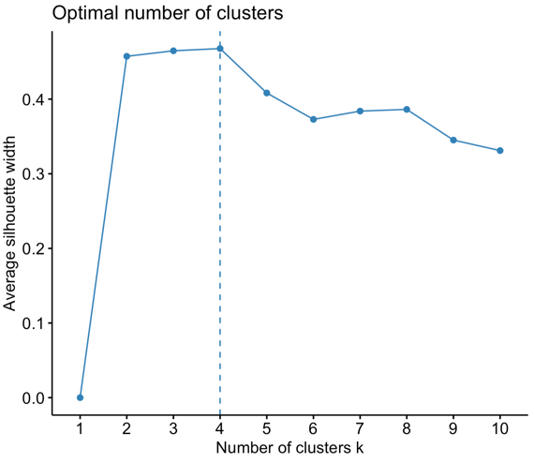

Figure 40: Graph for Optimal number of clusters using silhouette method with kmeans

The x-axis of this plot represents Number of clusters and y-axis of the plot represents Average Silhouette width.

From the above plot, it is clear that optimal number of clusters are 4 with highest average silhouette width.

* K-Means Clustering model with K as 4

As optimal number of clusters is 4 using Silhouette method, we will build K-Means clustering model with K as 4.

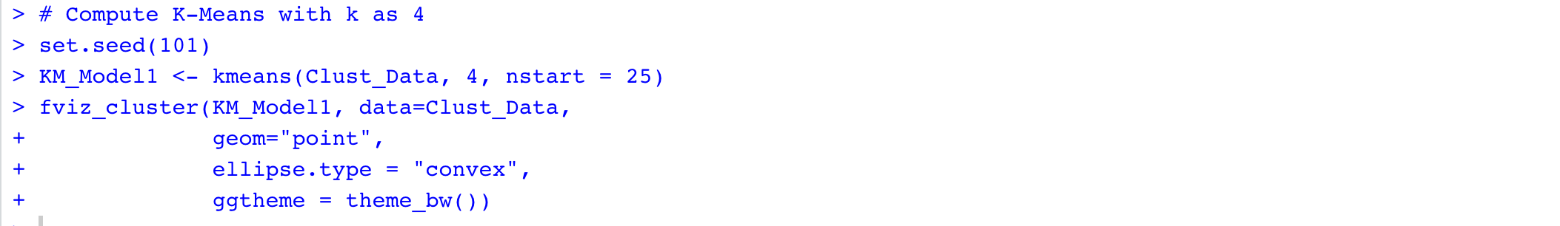

Figure 41: KM_Model1 - KMeans model with K as 4

Below is the graph of 4 clusters by K-means algorithm

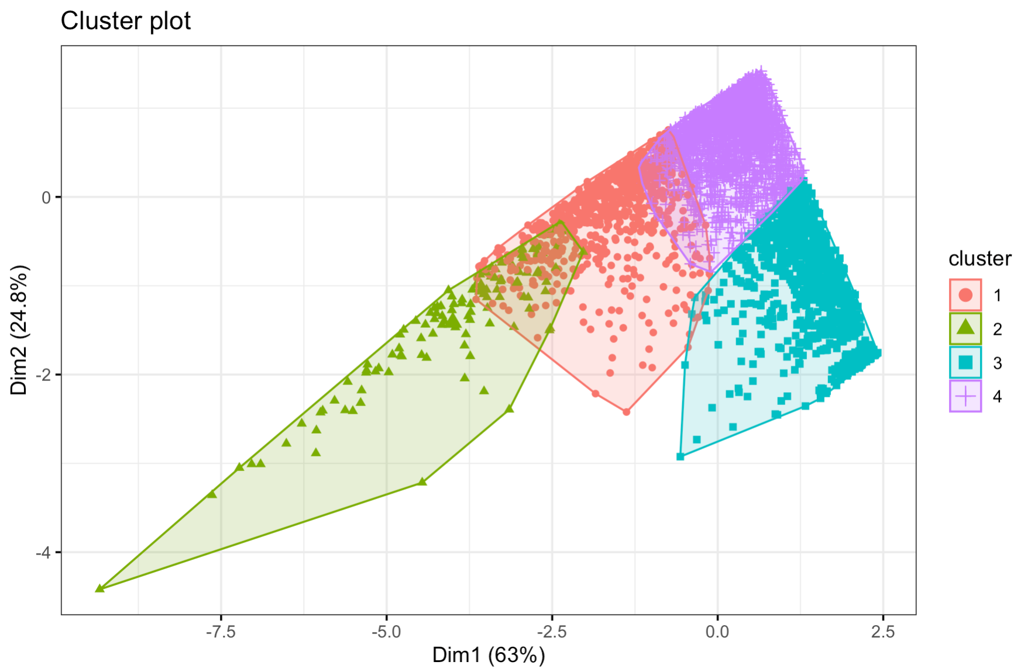

Figure 42: KM_Model1 - Graph of clusters

The total data was partitioned into 4 clusters based on their characteristics.

From the graph, the data points with different colors indicates the points in different clusters.

The size and centers of these clusters are as below

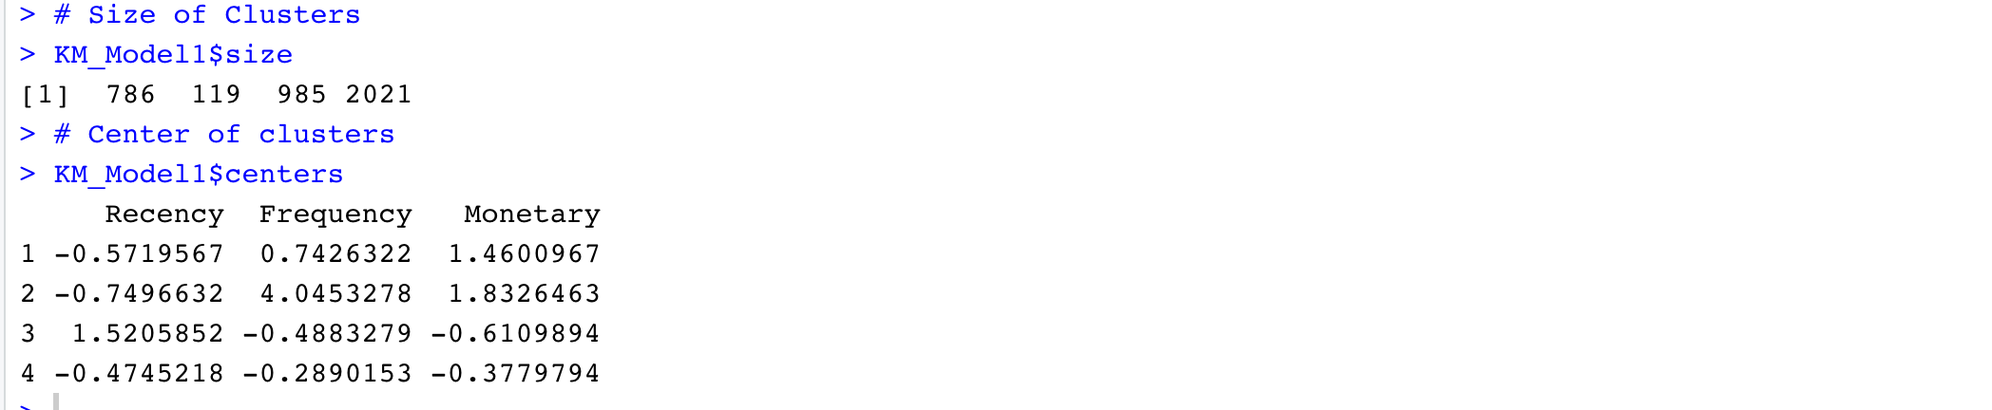

Figure 43: KM_Model1 - Size and Centers of Clsuters

* Calculate optimal number of clusters using Elbow method.

We calculate optimal number of clusters with K-means algorithm for the data using Elbow method.



Figure 44: Calculate optimal number of clusters using Elbow Method with kmeans

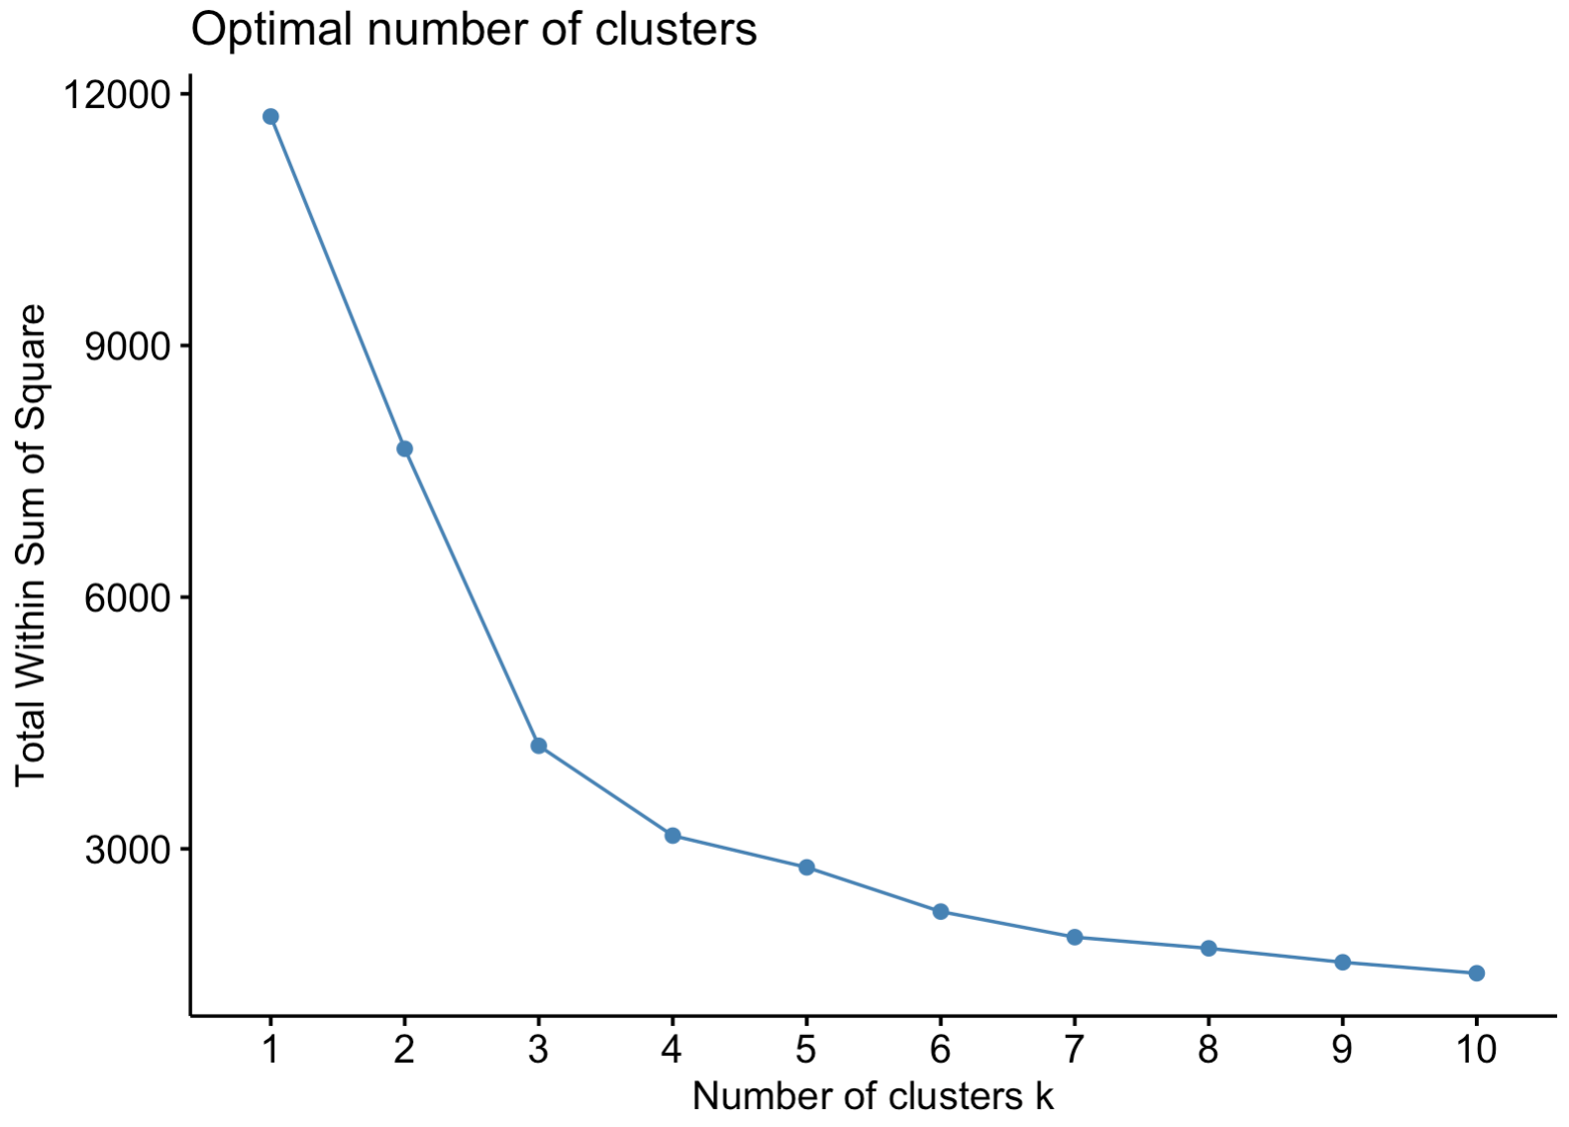

Figure 45: Graph of optimal number of clusters using Elbow method with kmeans

The x-axis of the above plot represents Number of clusters and the y-axis represents Total Within Sum of square.

In the above plot, the elbow of the curve is clearly at point 3. Therefore, the optimal number of clusters are 3 for data with k-means algorithm using elbow method.

* K-Means Clustering model with K as 3

As optimal number of clusters is 3 using Elbow method, we will build K-Means clustering model with K as 3.

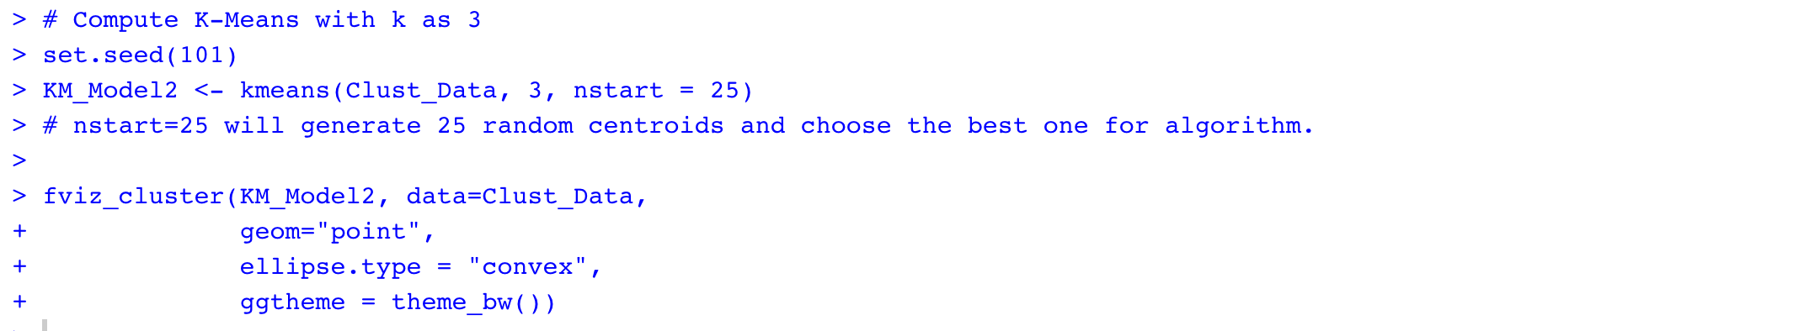

Figure 46: KM_Model2 - KMeans model with K as 3

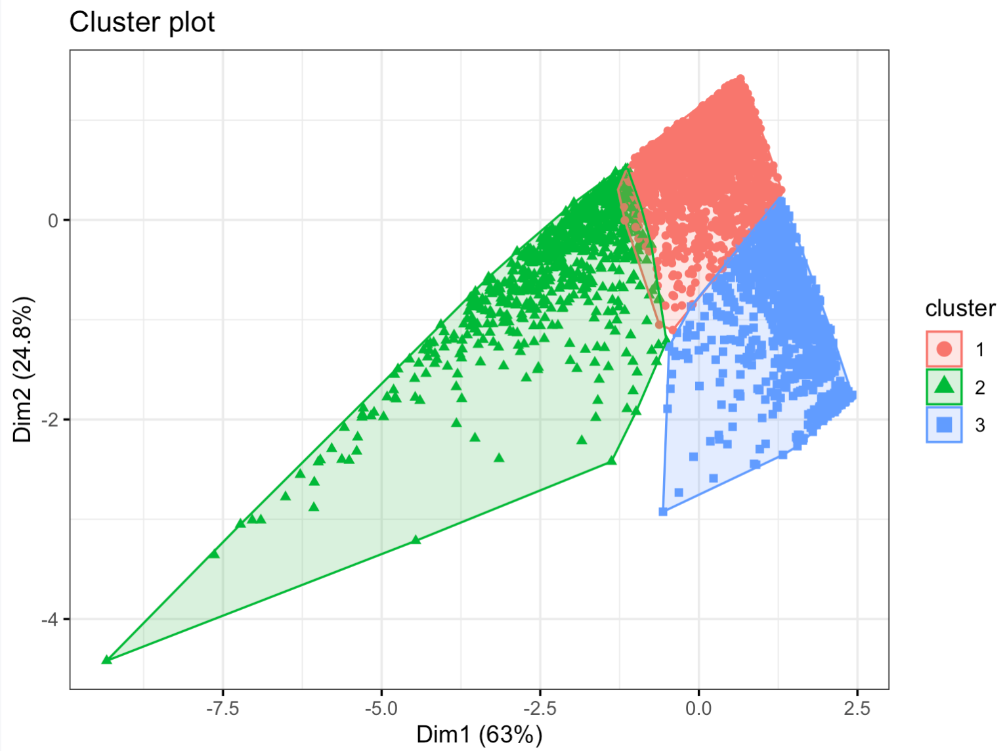

Figure 47: KM_Model2 - Graph of Clusters

The total data was partitioned into 3 clusters based on their characteristics using K-means algorithm.

From the graph, the data points with different colors indicates the points in different clusters.

The size and centers of these clusters are as below

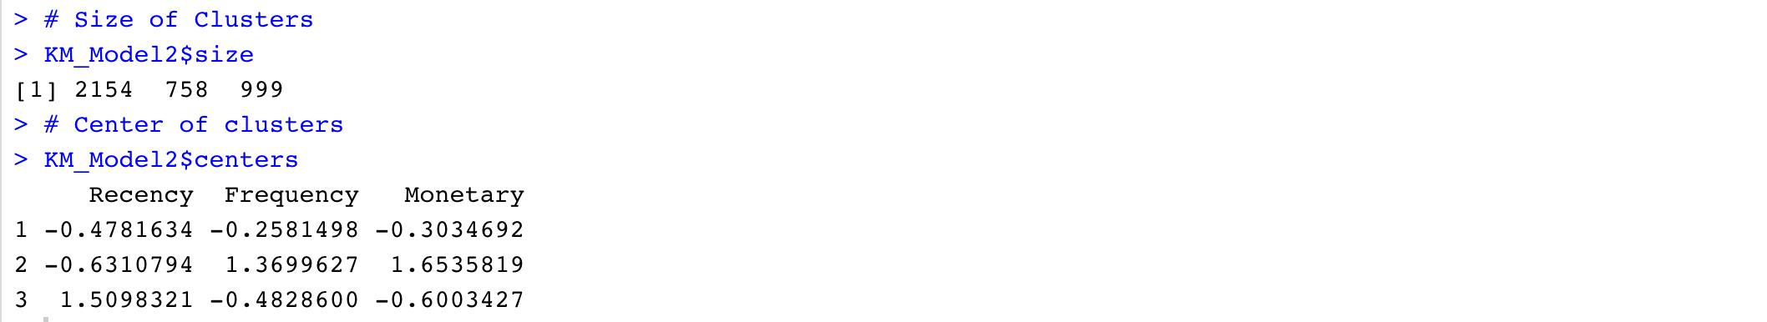

Figure 48: KM_Model2: Size and Centers of Cluster

## 4.2.1.2. Hierarchical Clustering

Hierarchical Clustering is only of the clustering techniques that builds the hierarchy of clusters.

* Calculate optimal number of clusters using Silhouette method.

We calculate optimal number of clusters with hierarchical algorithm for the data using Silhouette method.



Figure 49: Calculate Silhouette score with hcut method

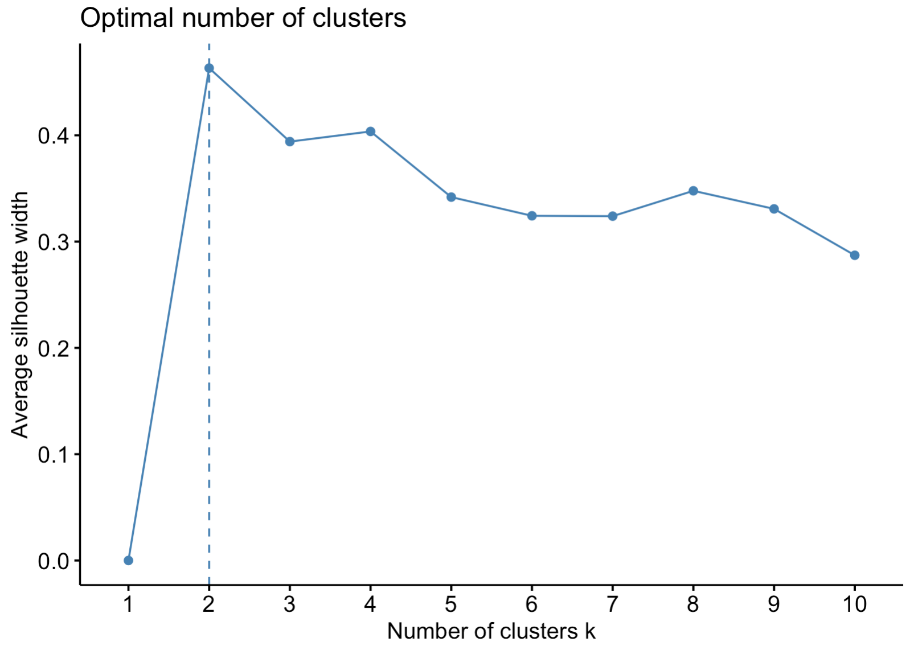

Figure 50: Graph for Optimal number of clusters using silhouette method with hcut

The x-axis of this plot represents Number of clusters and y-axis of the plot represents Average Silhouette width.

From the above plot, it is clear that optimal number of clusters are 2 with highest average silhouette width.

* Hierarchical Clustering model with K as 2

As optimal number of clusters is 2 using Silhouette method, we will build Hierarchical clustering model with K as 2.

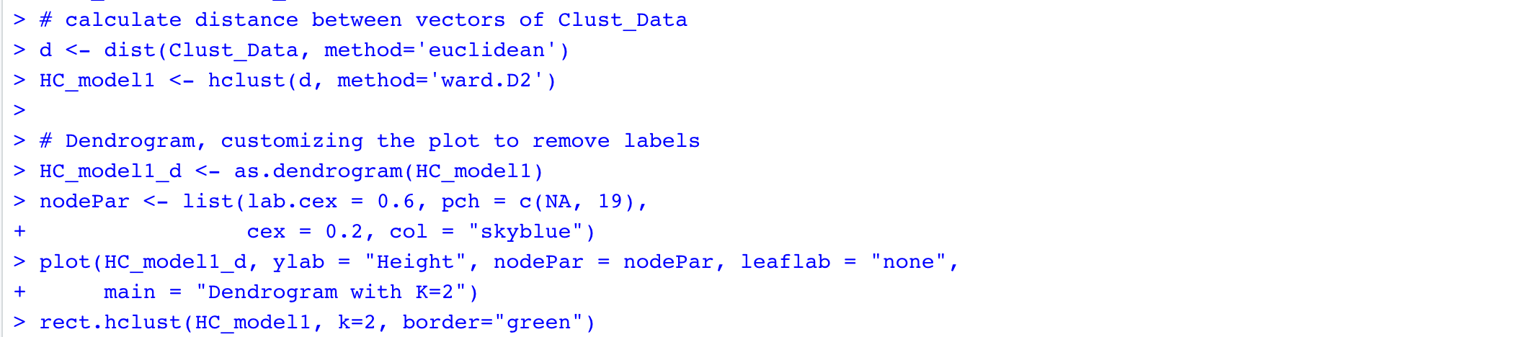

Figure 51: HC_Model1 - Hierarchical model with K as 2

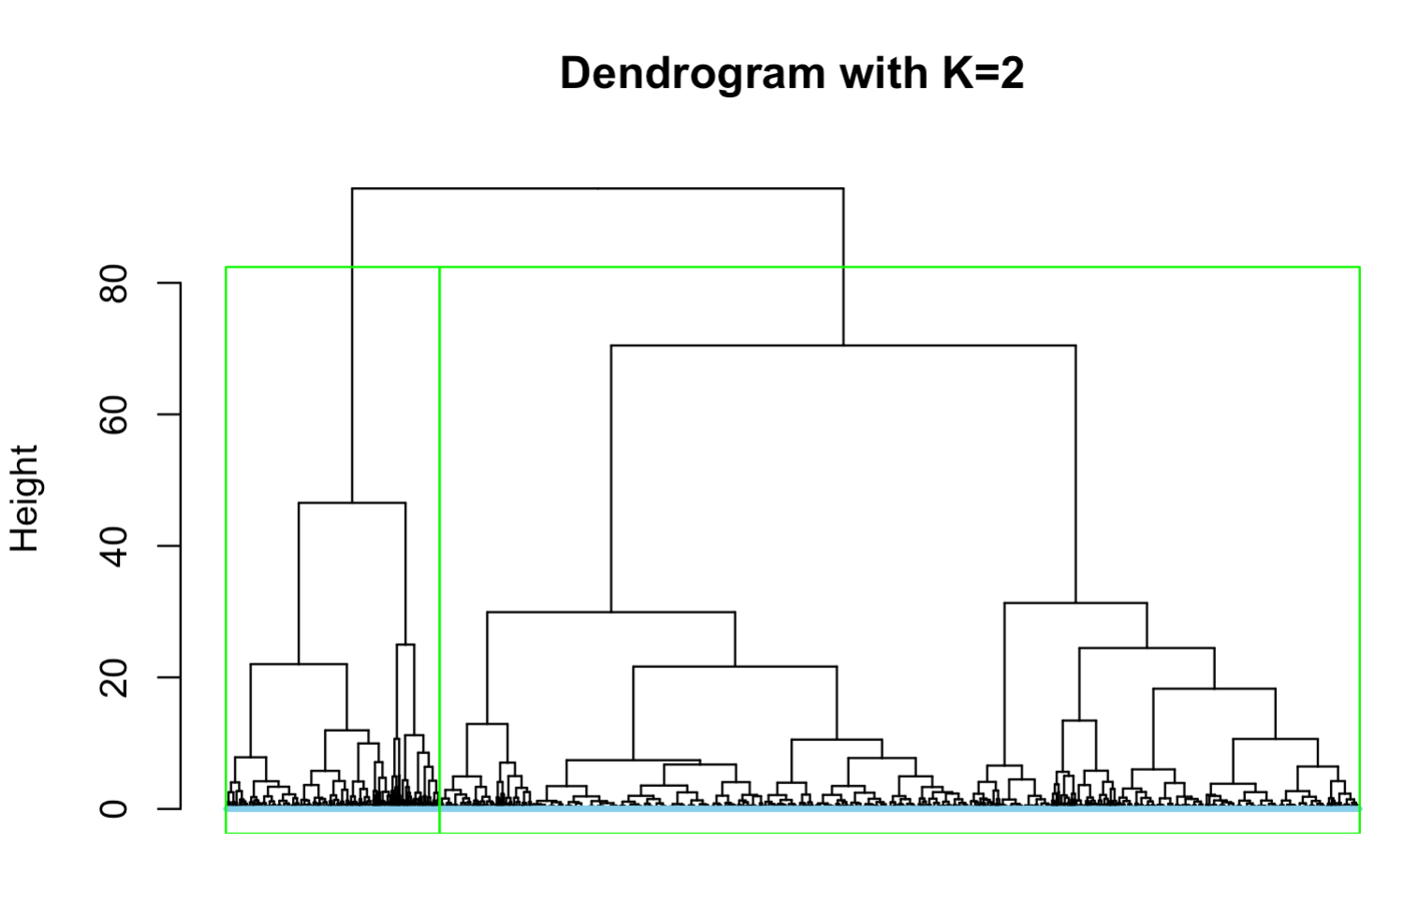

Figure 52: HC_Model1 - Dendrogram

The total data was partitioned into 2 clusters based on their characteristics using hierarchical clustering algorithm.

In the above dendrogram, total data is partitioned in two hierarchical clusters (green line indicates the partition).

The size and centers of the clusters is as below

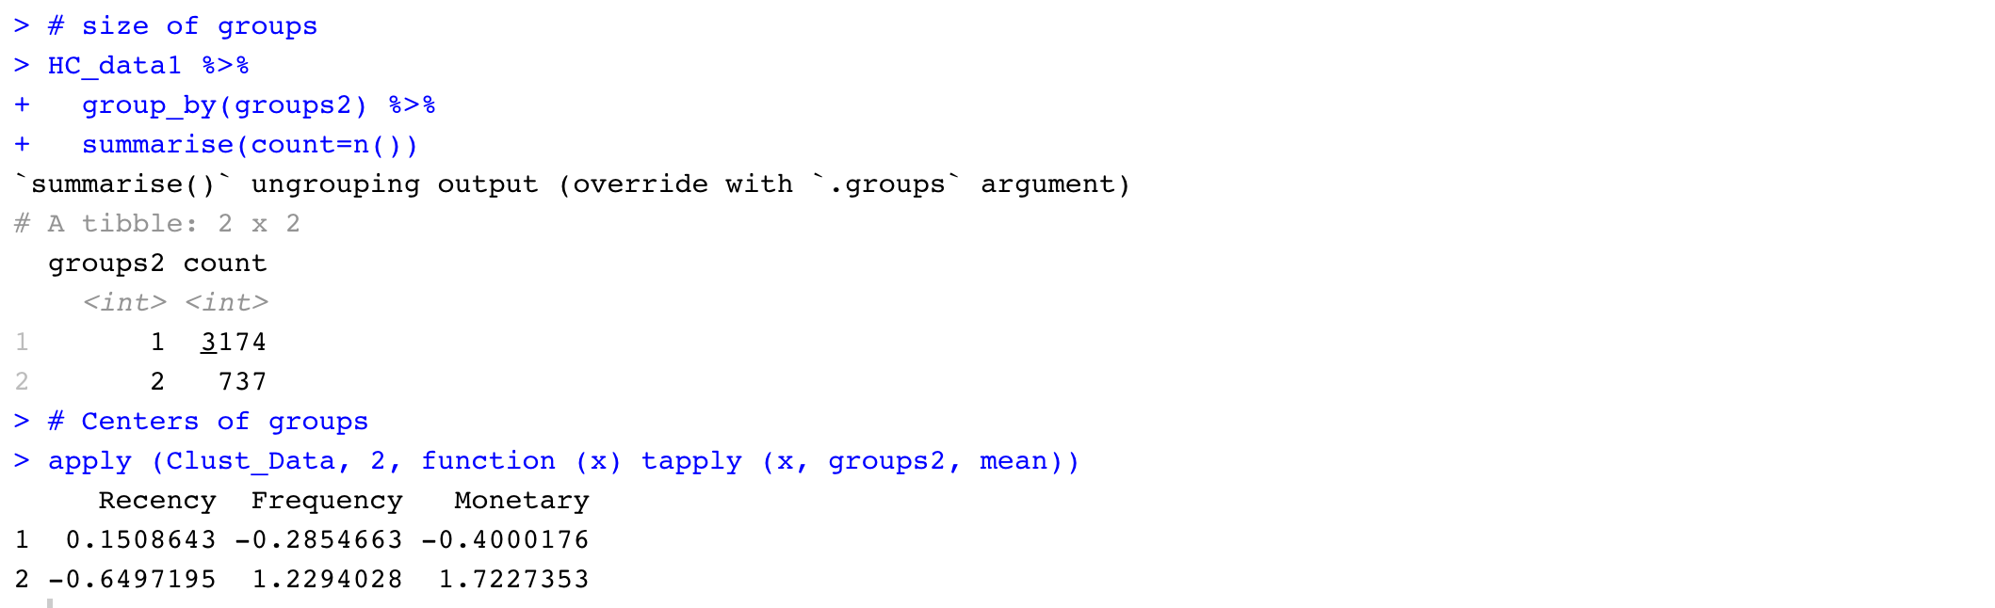

Figure 53: HC_Model1 - Size and Centers of clusters

* Calculate optimal number of clusters using Elbow method.

We calculate optimal number of clusters with hierarchical algorithm for the data using Elbow method.



Figure 54: Calculate optimal number of clusters using Elbow Method with hcut

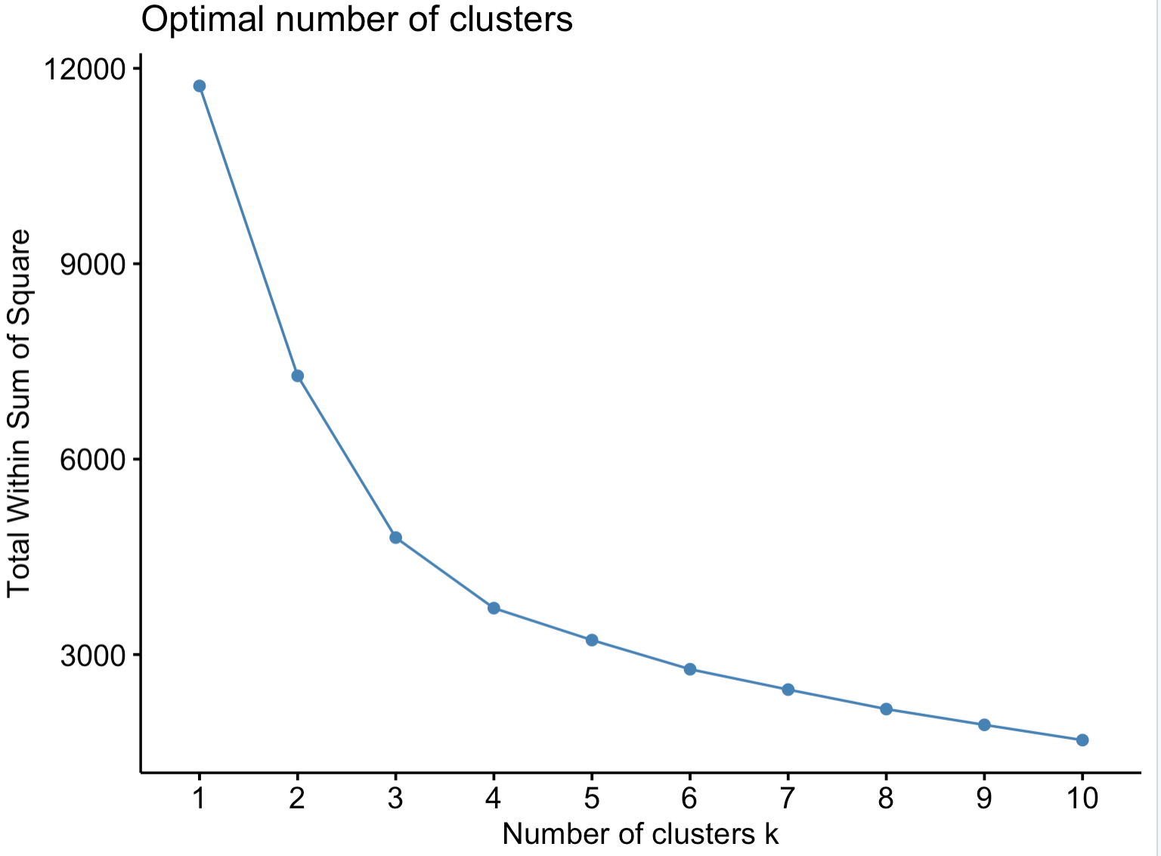

Figure 55: Graph of optimal number of clusters using Elbow method with hcut

The x-axis of the above plot represents Number of clusters and the y-axis represents Total Within Sum of square.

In the above plot, the elbow of the curve is clearly at point 3. Therefore, the optimal number of clusters are 3 for data with hierarchical algorithm using elbow method.

* Hierarchical Clustering model with K as 3

As optimal number of clusters is 3 using Elbow method, we will build Hierarchical clustering model with K as 3.

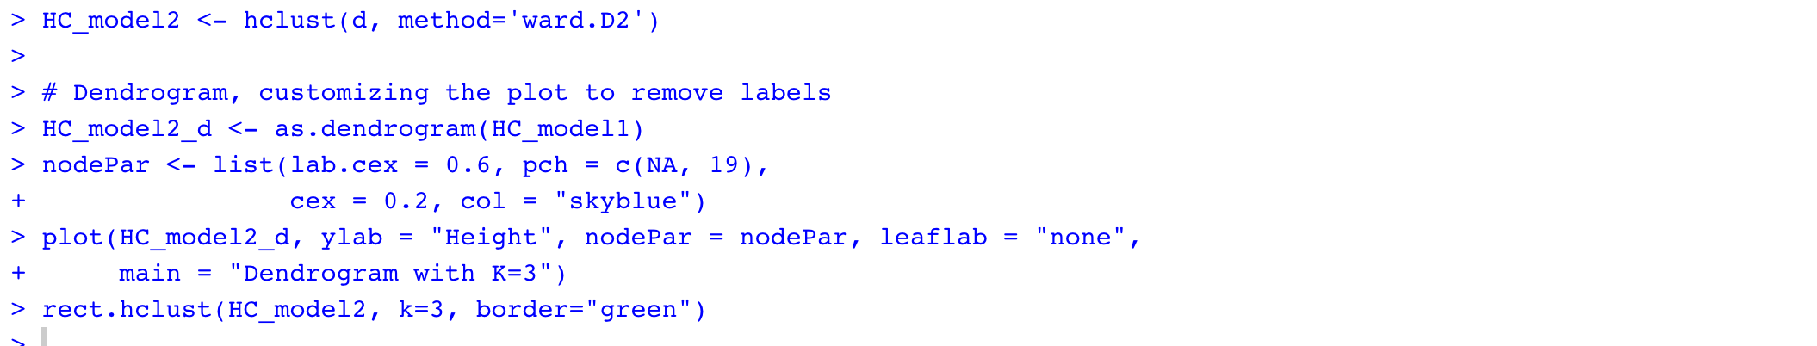

Figure 56: HC_Model2 - Hierarchical model with k as 3

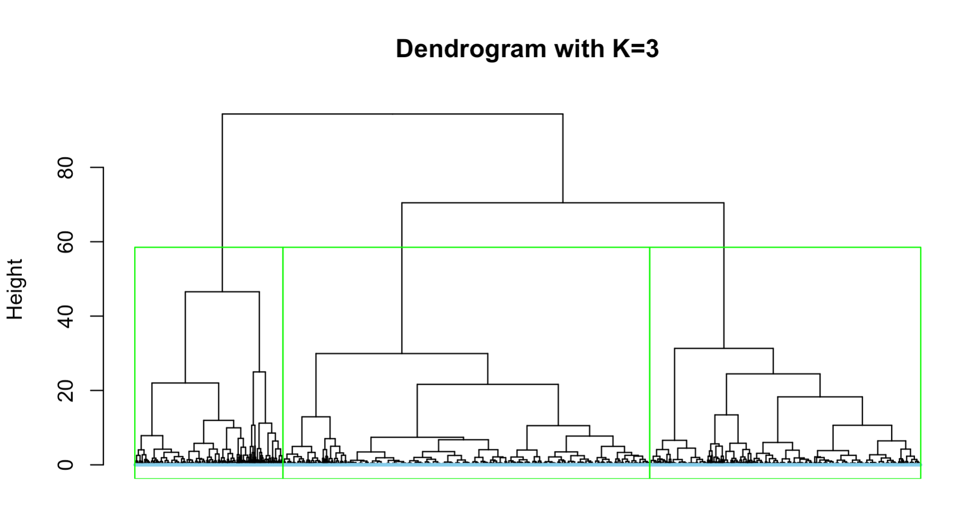

Figure 57: HC_Model2 - Dendrogram

The total data was partitioned into 3 clusters based on their characteristics using hierarchical clustering algorithm.

In the above dendrogram, total data is partitioned in 3 hierarchical clusters (green line indicates the partition).

The size and centers of the clusters is as below

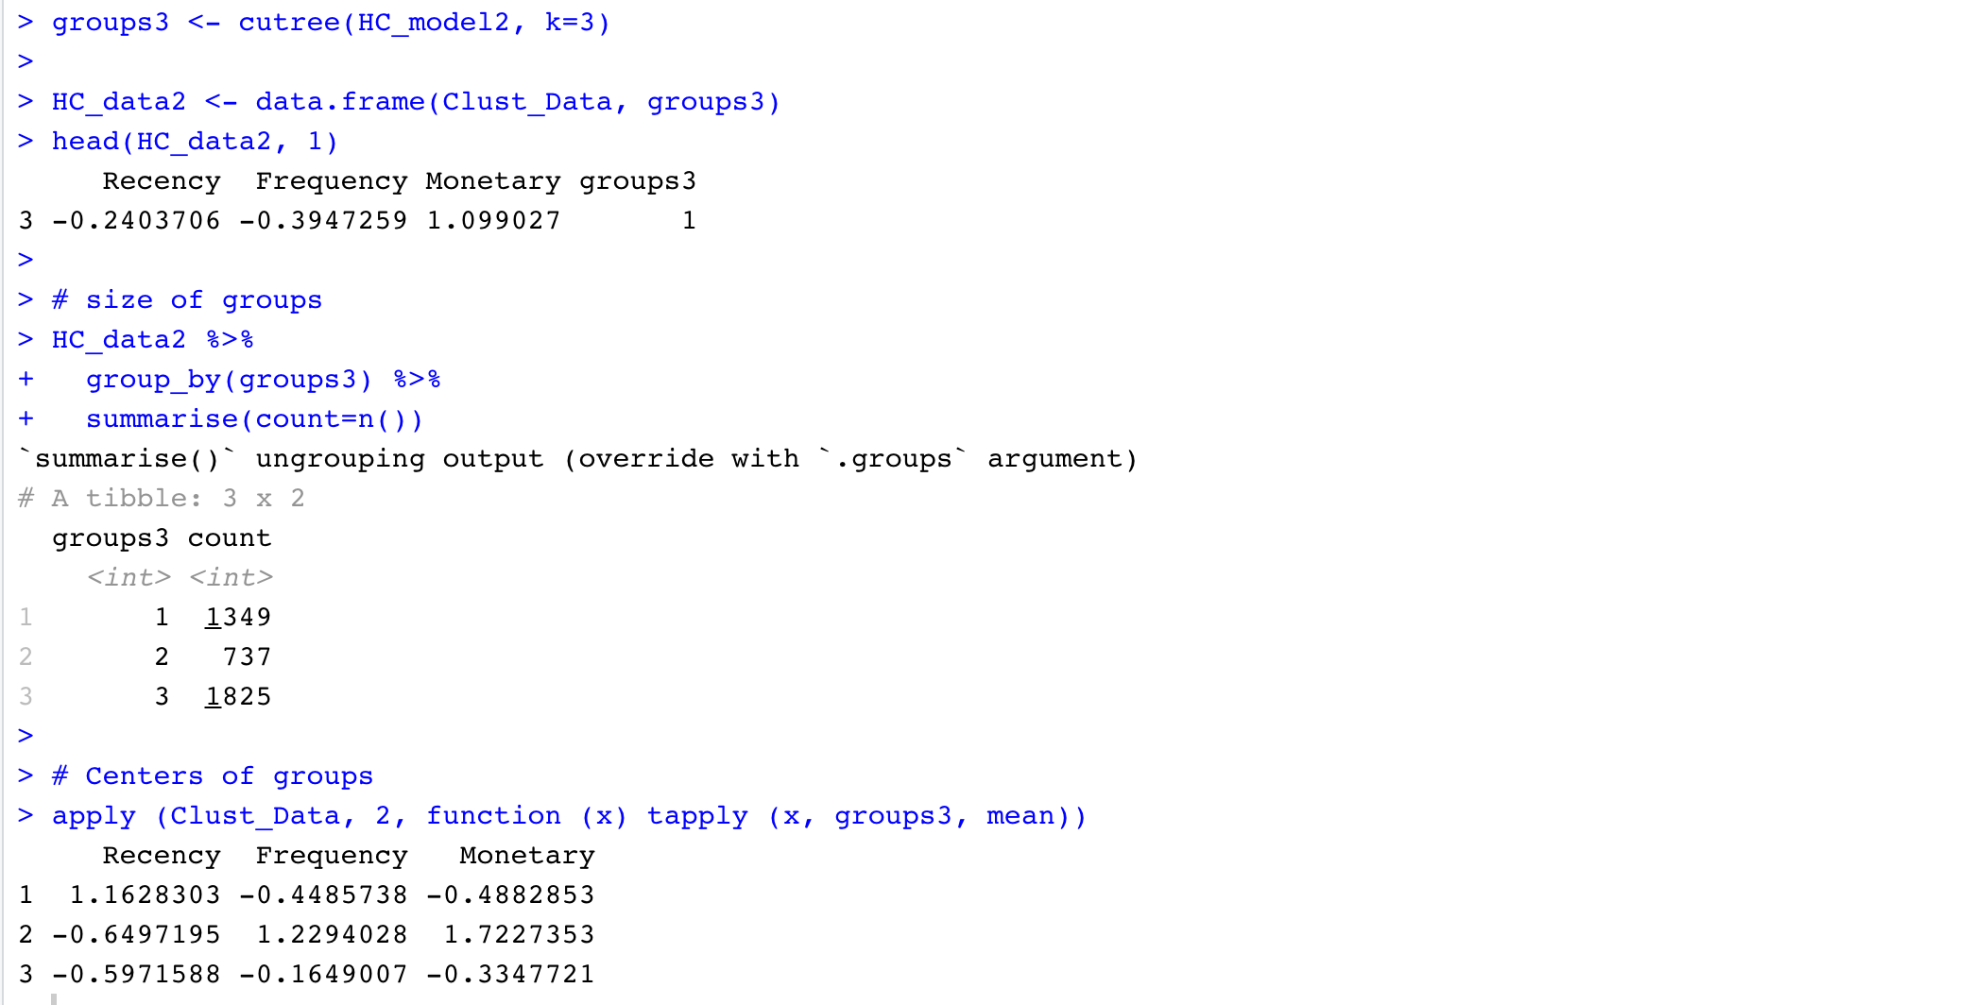

Figure 58: HC_Model2 - Size and Centers of cluster

## 4.2.2. Identify best 10 Association rules for the products in the online retail

We will be using Association rules mining technique in order to know the products that are frequently bought together.

To generate association rules, the data should be in transactions format. Therefore, read the data from csv file as transactions.



Figure 59: Read the data as transactions

* Generate association rules using Apriori Algorithm

Apriori Algorithm is using to find frequent item sets and their relevant association rules.

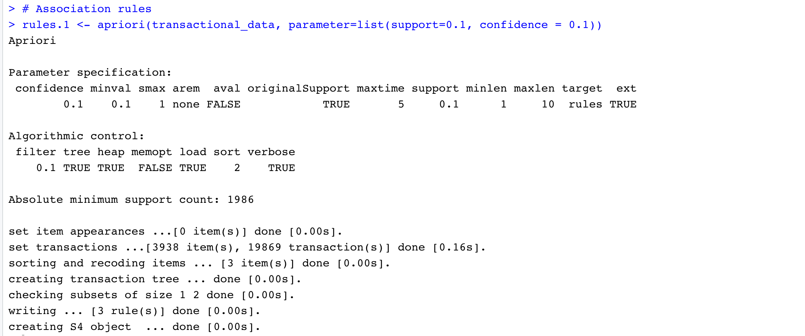

Figure 60: Association rules with min.support 0.1 and min.confidence 0.1

With minimum support of 0.1 and minimum confidence of 0.1, 3 rules have been generated.

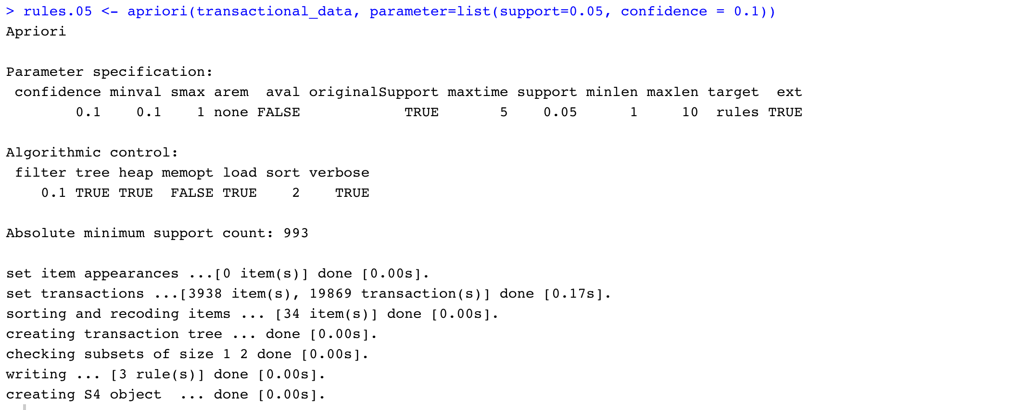

Figure 61: Association rules with min.support 0.05 and min.confidence 0.1

With minimum support of 0.05 and minimum confidence of 0.1, 3 association rules have been generated for the products bought together.

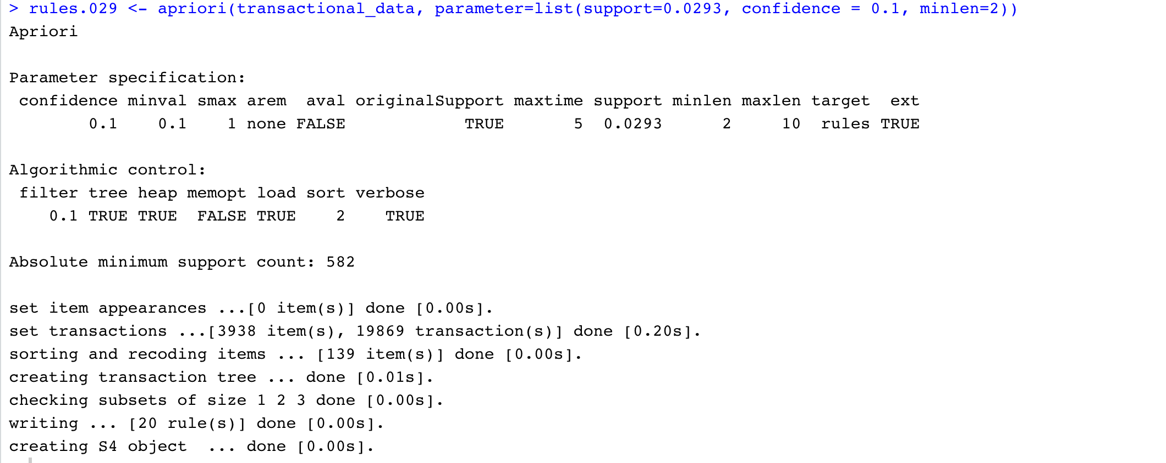

Figure 62: Association rules with min.support 0.0293 and min.confidence 0.1

With minimum support of 0.0293 and minimum confidence of 0.1, 20 association rules have been generated for the products bought together.

Inspect the 20 association rules ordered by confidence

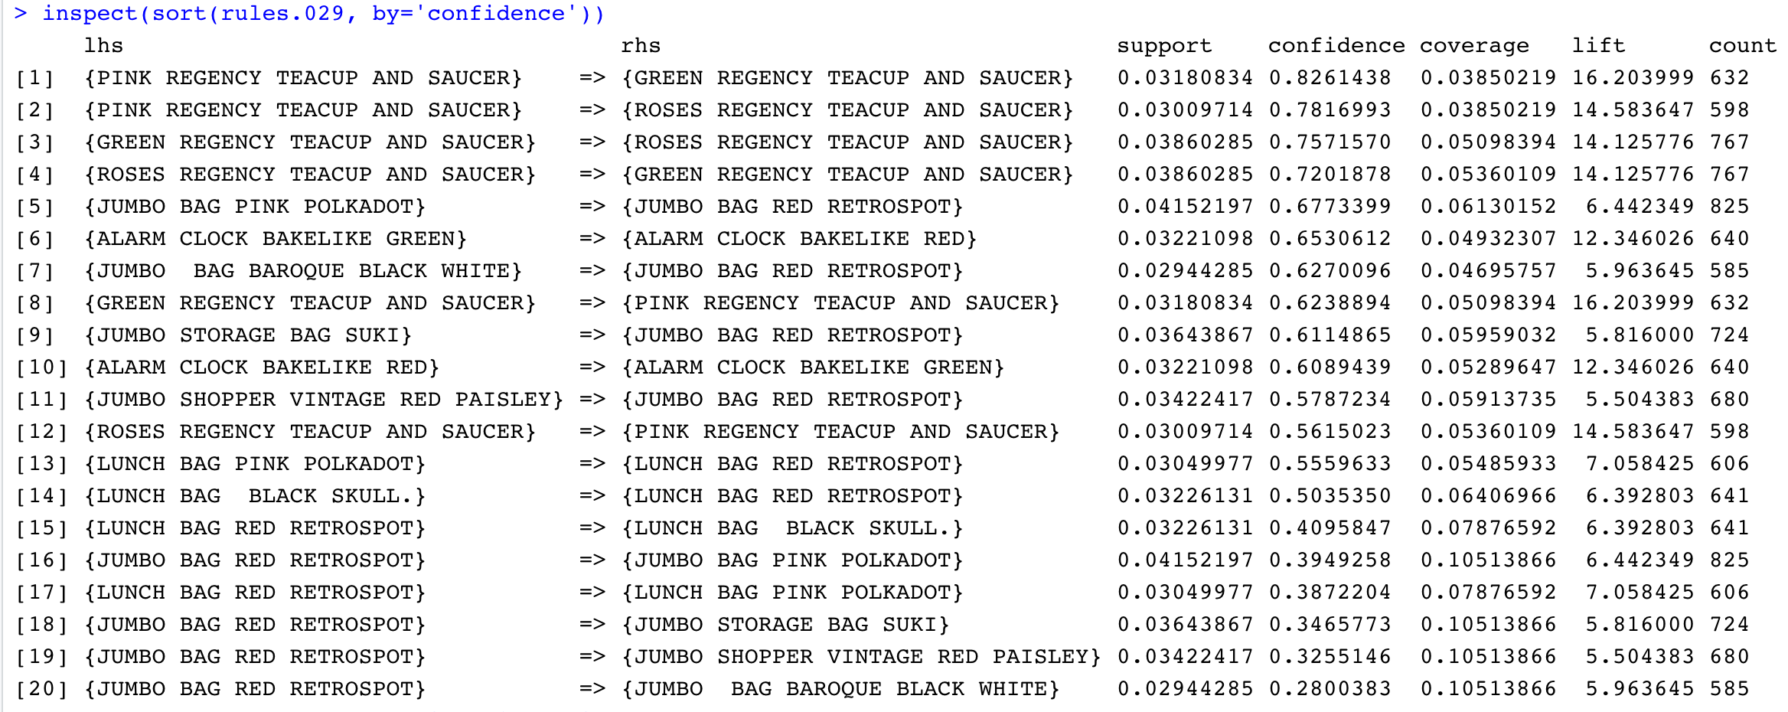

Figure 63: Inspect Association rules

If we observe the above association rules, some rules are redundant.

For example, we have association rules

{GREEN REGENCY TEACUP AND SAUCER} => {ROSES REGENCY TEACUP AND SAUCER}

{ROSES REGENCY TEACUP AND SAUCER} => {GREEN REGENCY TEACUP AND SAUCER}

These both rules indicate that the products GREEN REGENCY TEACUP AND SAUCER and ROSES REGENCY TEACUP AND SAUCER are frequently bought together. So, there is no point in having two same rules. In order to avoid these types of redundant rules and get valid rules, we will prune redundant rules

* Prune the redundant rules

We prune the redundant rules by checking is any rule, a subset of other rules.

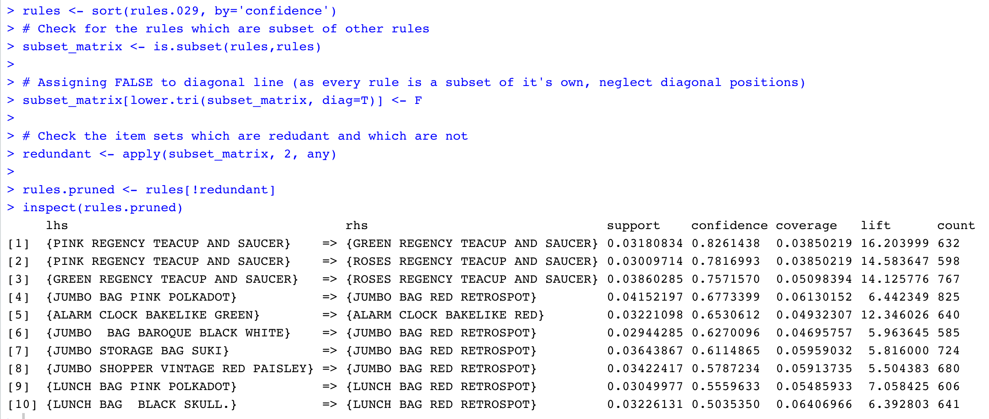

Figure 64: Prune the Redundant rules

Finally, we have got 10 valid association rules with minimum support 0.0293 and minimum confidence 0.1.

# **5. Evaluations and Results**

## 5.1. Evaluation Methods

There are no clear evaluations for unsupervised learning techniques. Clustering is good as long as it can serve the usage. Association rules are good as long as they have much support and we can interpret the results.

## 5.1.1. Identify the Customers into different groups based on their behavior with the online retail.

For clustering models, we have two main evaluation measures to validate the results.

1. Internal measures and
2. External measures

Internal measures evaluate the quality of clusters based on the data.

External measures evaluate the quality of clusters using external knowledge i.e., class labels.

## 5.1.1.1. Internal measures

There are three Internal measures they are Connectivity, silhouette width and Dunn Index

**Connectivity:** Degree of connectedness of the clusters determined by KNN. This should be minimum.

**Silhouette width:** Measures the compactness of the clusters.

$S_{i}= \frac{(b_{i} - a_{i})}{max(a_{i},b_{i})}$

$a_{i}$ is the average distance of object i from all other objects of same cluster.

$b_{i}$ is the average distance of object i from all other objects of different cluster.

The range of $S_{i}$ is [-1,1].

**Dunn Index:** Measures the separation of clusters.

$$D= \frac{min.separation}{max.diameter}$$

This should be maximum.

We calculate internal measures for the clustering models using both kmeans and hierarchical methods for values of k 2,3 and 4.

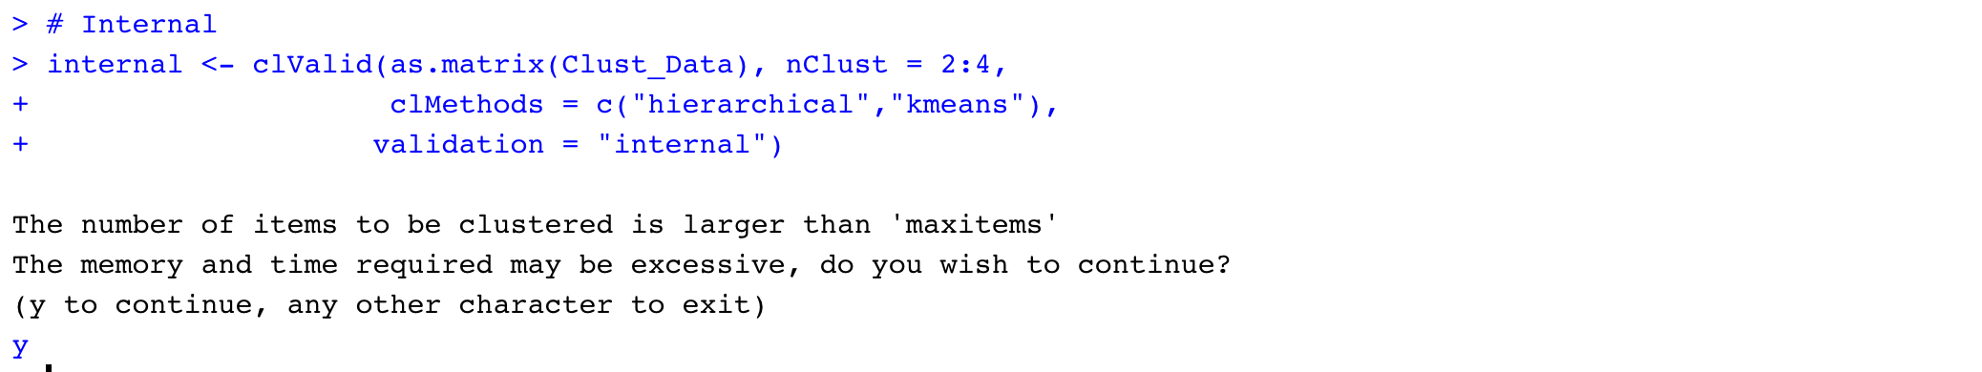

Figure 65: Calculate Internal measures

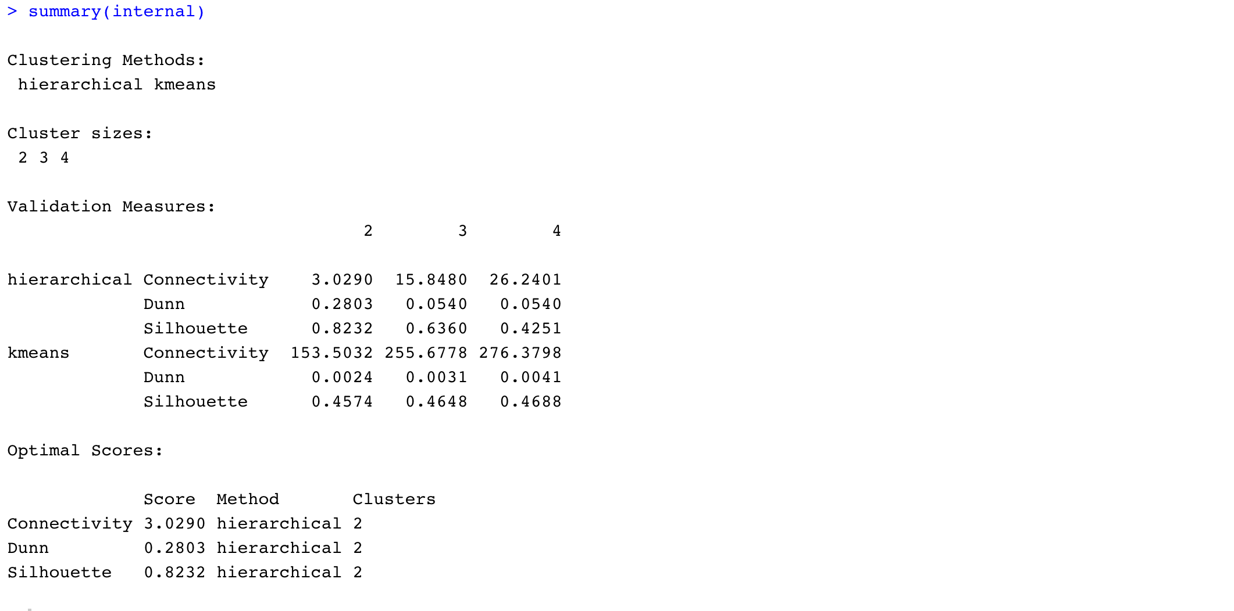

Figure 66: Summary of Internal measures

Connectivity, Dunn Index and Silhouette width are calculated for all the clustering models build using Kmeans and hierarchical algorithms for values of K 2,3 and 4.

Comparing all the internal measure values of all the models, we have got optimal scores for hierarchical clustering model with K as 2.

Using Internal validation measures, we can conclude that for the given data the hierarchical clustering model with two clusters is the best fit.

## 5.1.1.2. External measures

As the data is not pre-labeled, we cannot use External validation measures like Accuracy by implementing Classification techniques.

## 5.1.1.3. Manual Evaluation

* Compare the centroids of clusters.

We can compare the centroids of clusters and check whether the centroids are significantly different from each other

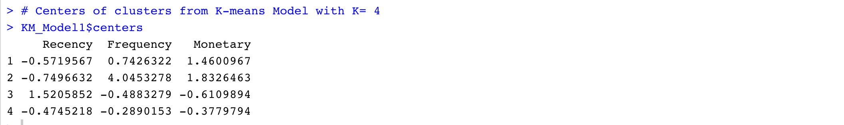

Figure 67: KM_Model1 - Centers of Clusters

Comparing the centers of KM_Model1 (Kmeans clustering model with K as 4) clusters, there is no significant difference between the Recency values of cluster1, cluster2 and cluster4. There is also no significant difference between the Frequency values of cluster3 and cluster4.

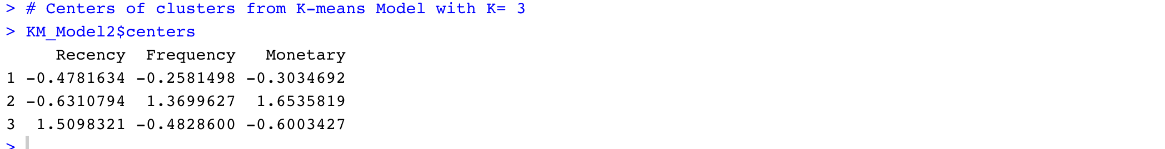

Figure 68: KM_Model2 - Centers of Clusters

Comparing the centers of KM_Model2 (Kmeans clustering model with K as 3) clusters, there is no significant difference between the Recency values of cluster1, cluster. There is also no significant difference between the Frequency values of cluster1 and cluster3.



Figure 69: HC_Model1 - Centers of Clusters

Comparing the centers of HC_Model1(Hierarchical clustering model with K as 2) clusters, there is significant difference between the Recency, Frequency and Monetary values of cluster1 and cluster2.

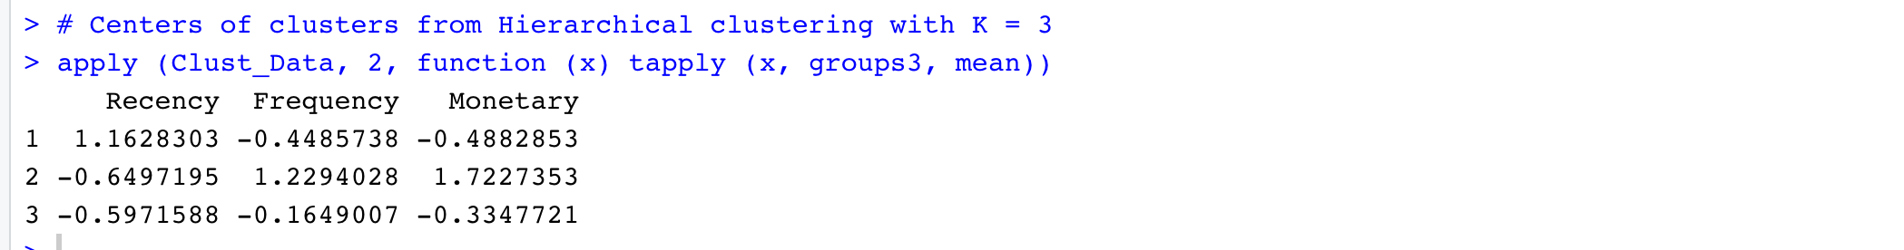

Figure 70: HC_Model2 - Centers of Clusters

Comparing the centers of HC_Model2(Hierarchical clustering model with K as 3) clusters, there is no significant difference between the Recency values of cluster2 and cluster3. There is also no significant difference between Monetary values of cluster1 and cluster3.

Therefore, both from Internal validation measures and Manual evaluations, Hierarchical Clustering model with clusters 2 is the best model.

## 5.1.2. Identify best 10 Association rules for the products in the online retail

Association rules can be evaluated with the Rule evaluation metrics i.e., Support, Confidence and lift.

For association rule $\left\{X\right\}→\left\{Y\right\}$

**Support**

Support measures how frequent the product set is in all the transactions.

$$Support \left(\left\{X\right\}→\left\{Y\right\}\right)= \frac{Transactions containing both X and Y}{Total Transactions}$$

**Confidence**

Confidence measures the likeliness of buying product Y, having product X in the Basket.

$$Confidence \left(\left\{X\right\}→\left\{Y\right\}\right)=\frac{Transactions containing both X and Y}{Transactions containing X}$$

**Lift**

Lift is the rise in probability of buying product Y with product X in the basket over the probability of buying product Y without having the product X in the basket.

$$Lift \left(\left\{X\right\}→\left\{Y\right\}\right)= \frac{(Transactions containing both X and Y)/(Transactions containing X)}{Fraction of transcations containing Y}$$

Top 10 Association rules with their Support, Confidence and Lift values is as below

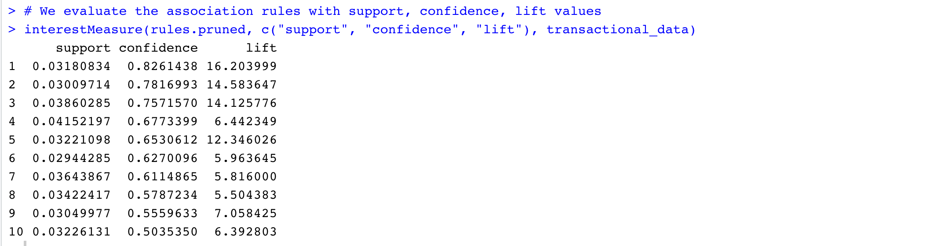

Figure 71: Association rules - Support, Confidence, Lift values

In the given data 0.04 is the minimum support (best for the data), with which we can generate association rules.

The confidence of the top association rule is also good with 82.6%.

Lift value close to 1 indicates X and Y almost often appear together as expected, greater than 1 indicates, X and Y appear together more than expected and less than 1 indicates, X and Y appear less than expected. Greater lift values indicate stronger association.

The lift value of all the association rules is greater than 1 which indicates X and Y appear together more than expected. Expected is nothing but the Fraction of transactions containing only Y.

All the rules are generated with more than 50% confidence, lift value more than 1 and with minimum support 3% (best we got for the given data). We are considering these rules are good fit.

## 5.2. Results and Findings

## 5.2.1. Identify the Customers into different groups based on their behavior with the online retail.

* Interpreting the results

From the above evaluations, hierarchical clustering model with 2 clusters is the best model for customer segmentation of an online retail.

Divide the customers into 2 different groups using hierarchical clustering model.

The below are the size of the clusters.

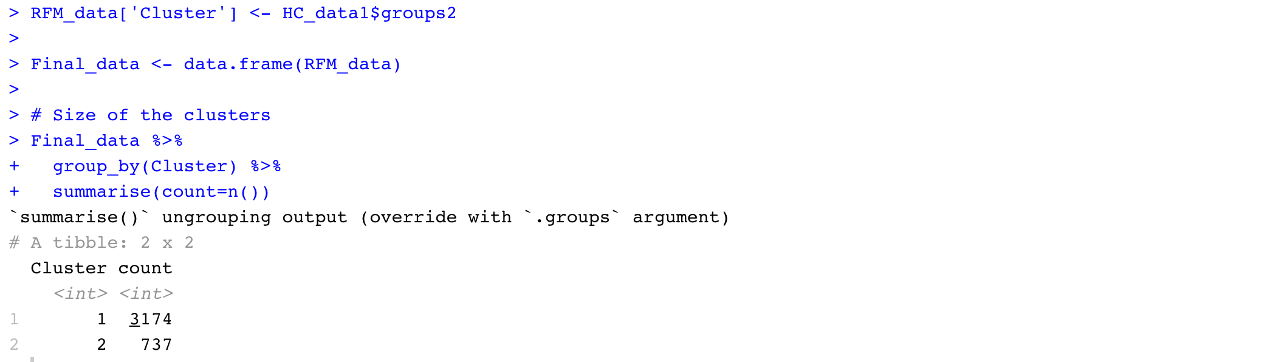

Figure 72: Size of the final clusters

Summary of the final data is as below

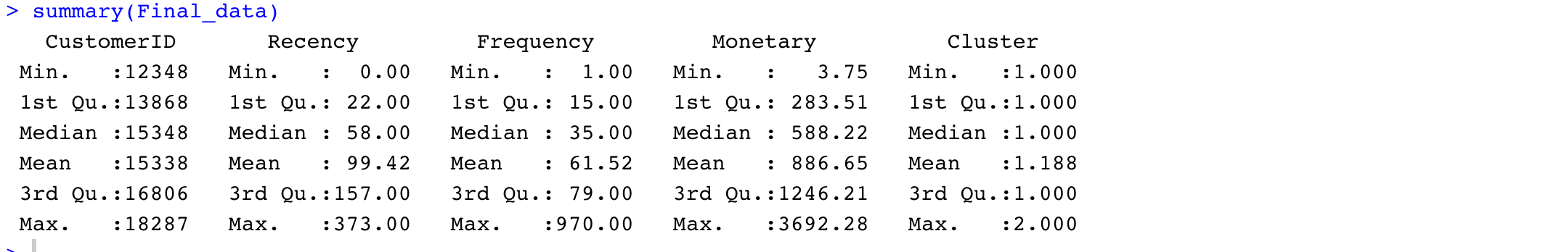

Figure 73: Summary of Final data

Some of the customers from group 1

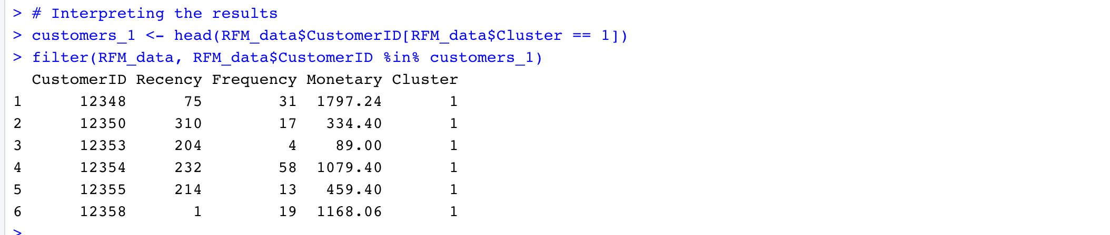

Figure 74: Customers of Group1

For customer1, Recency and Frequency value is less whereas Monetary value is more compared to their respective means.

For customer2, Recency value is more whereas Frequency and Monetary values are less compared to their respective means.

From the above data, we can infer that Cluster 1 is of the customers who are either with More Recency or Less Frequency or Less Monetary in the online Retail.

Some of the customers from group 2

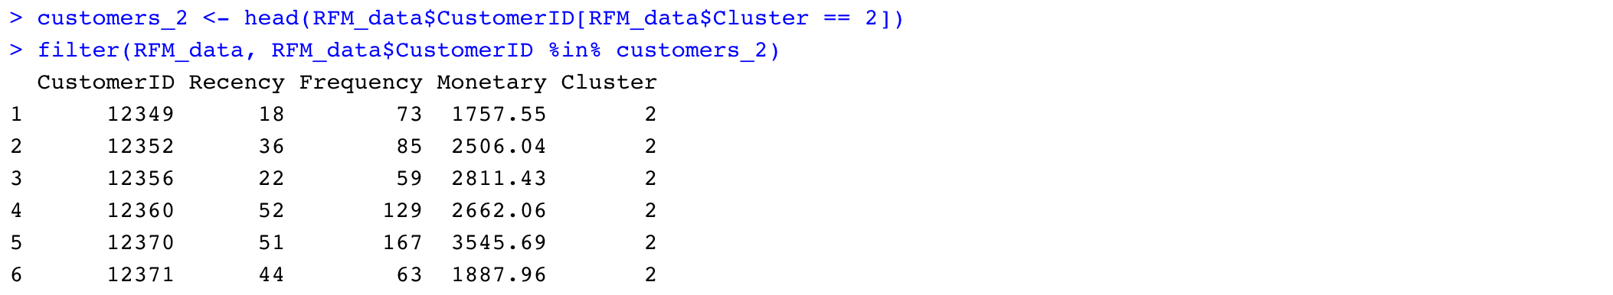

Figure 75: Customers of Group2

For all the above customers Recency value is less, Frequency is more and Monetary is more compared to their respective means. Therefore, these are the customers who visited recently, frequently and spent good amount to the online retail.

Therefore, Group 2 customers are identified as Loyal customers.

## 5.2.2. Identify best 10 Association rules for the products in the online retail

The best 10 association rules for the products in the online retail are as below

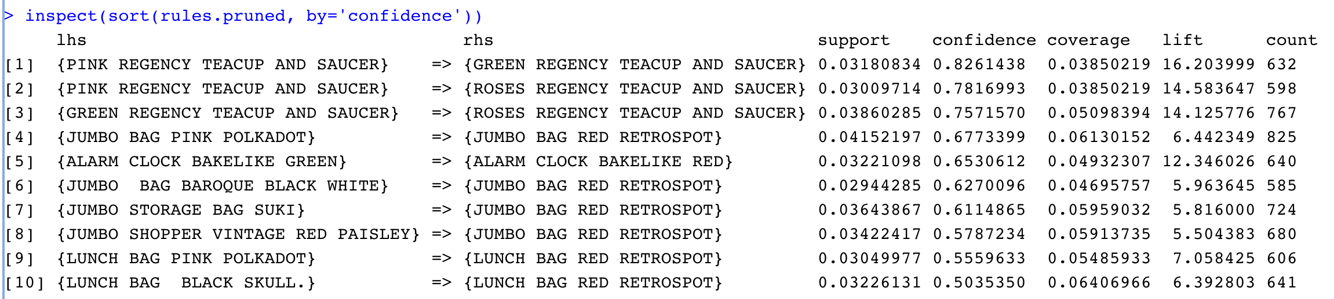

Figure 76: Best 10 Association rules

Above are the association rules with min.support 0.0293 and min.confidence 0.1.

The support which we got is the best for the given data.

The confidence of the top association rule is good with 82.6%.

The lift value of all the association rules is greater than 1 which indicates X and Y appear together more than expected. Expected is nothing but the Fraction of transactions containing only Y.

The visual graph for the association rules is as below

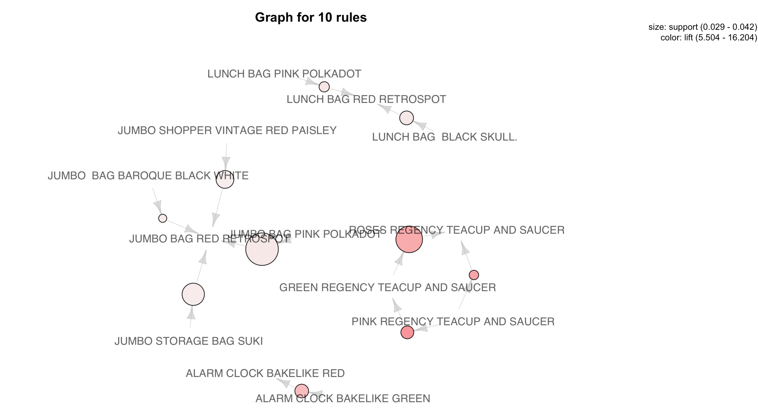

Figure 77: Graph of Best 10 Association rules

# **6. Conclusions and Future Work**

## 6.1. Conclusions

* Customer Segmentation

Customers of online-retail have been segmented into two groups using their Recency, Frequency and Monetary values.

Group 1 are with the customers who are either not recent nor frequent nor spent good amount to the online retail.

Group 2 are the customers who are recent, frequent and spent good amount to the online retail.

Group 2 customers are identified as Loyal Customers.

* Market Basket Analysis

Following are the products that bought together along with their association ordered by confidence.

{PINK REGENCY TEACUP AND SAUCER} => {GREEN REGENCY TEACUP AND SAUCER}

{PINK REGENCY TEACUP AND SAUCER} => {ROSES REGENCY TEACUP AND SAUCER}

{GREEN REGENCY TEACUP AND SAUCER} => {ROSES REGENCY TEACUP AND SAUCER}

{JUMBO BAG PINK POLKADOT} => {JUMBO BAG RED RETROSPOT}

{ALARM CLOCK BAKELIKE GREEN} => {ALARM CLOCK BAKELIKE RED}

{JUMBO BAG BAROQUE BLACK WHITE} => {JUMBO BAG RED RETROSPOT}

{JUMBO STORAGE BAG SUKI} => {JUMBO BAG RED RETROSPOT}

{JUMBO SHOPPER VINTAGE RED PAISLEY} => {JUMBO BAG RED RETROSPOT}

{LUNCH BAG PINK POLKADOT} => {LUNCH BAG RED RETROSPOT}

{LUNCH BAG BLACK SKULL.} => {LUNCH BAG RED RETROSPOT}

## 6.2. Limitations

* The conclusions made for the online retail are limited to the transactions that occurred between 01/12/2010 and 09/12/2011.
* The customer segmentation is limited to K-Means and Hierarchical clustering algorithms.
* The calculation of optimal number of clusters is limited to Elbow method and silhouette method.

## 6.3. Potential Improvements or Future Work

* Use Gap-Statistic Method to find the optimal number of clusters for clustering.
* Use Density based and K-medoids clustering algorithms for Customer segmentation.
* Inspect Association rules with confidence levels 0.5, 0.6 and so...Business can use these rules in designing lossless promotional offers for the products.